**Style Guidelines for Final Year Project ReportsReview Hub**

**Final Year Project**

**Session 2013-2017**

A 4th Year Student

A project submitted in partial fulfilment of the

COMSATS-Lancaster Dual Degree

Of

BSc. (Hons.)BS in Computer Science / Software Engineering (CIIT)

BS in Computing / Software Engineering (LU)

**C:\Documents and Settings\drzhabib\Desktop\lancaster-university-logo.png**

Department of Computer Science

COMSATS Institute of Information Technology, Lahore

20 May 2017

**Project Detail**

|  |  |  |  |  |  |
| --- | --- | --- | --- | --- | --- |
| Type (Nature of project) | | [✓] **D**evelopment [ ] **R**esearch [ ] **R**&**D** | | | |
| Area of specialization | | Web technologies | | | |
| **Project Group Members** | | | | | |
| Sr.# | Reg. # | | Student Name | Email ID | *Signature |
| (i) | DDP-FA13-BCS-149 | | Talal Mirza | talalmirza55@gmail.com |  |
| (ii) | DDP-FA13-BCS-053 | | Humza Waseem Bhatti | humzawaseem95@gmail.com |  |
| (iii) | DDP-FA13-BCS-017 | | Ali Haider Babar | alihaider.babar0@gmail.com |  |

*The candidates confirm that the work submitted is their own and appropriate credit has been given where reference has been made to work of others

**Plagiarism Free Certificate**

This is to certify that, I am  **Talal Mirza** S/D/o  **Mirza Z, Babar Baig** , group leader of FYP under registration no **CIIT/DDP-FA13-BCS-149/LHR** at Computer Science Department, COMSATS Institute of Information Technology, Lahore. I declare that my FYP proposal is checked by my supervisor and the similarity index is ________% that is less than 20%, an acceptable limit by HEC. Report is attached herewith as Appendix A.

Date: /05/2017 Name of Group Leader: **Talal Mirza**  Signature: _____________

Name of Supervisor: Mr. Muhammad Adnan Ashraf Designation: Lecturer

Signature: _____________________

Co-Supervisor: Mr. Muhammad Mohsin Mehdi Designation: Lecturer

Signature: _____________________

HoD: _____________________

Signature: _____________________

**Abstract**

Web technologies is of the great importance to develop dynamic and interactive web based applications.The aims of this project is to build an online web based review site. Which will provide the professional reviews of products according to Pakistani market. Reviews serve as luxury to people which eradicate the risk while buying the product with knowledge about it or by knowing the performance as well. As a lot of online review content is available but the main focus of this project is Pakistani market. No prominent or solidary platform is in place to tackle and respond according to the local trends and psyche of customers. Where this web application will reflect according to the trend among major in-demand categories, which includes mobile phones, movies, food, technology gadgets and devices. In which reviews will be posted by hired food critics, film critics and technology enthusiasts. All these hired proficient will have their own ranks ranked according to quality of their reviews.

**Acknowledgement**

First of all we would like to thank to Allah Almighty, Who helped us to the powerful achievement of the final year project. Without His help we were not able to finish our FYP-1 report. A special thanks to our final year project Supervisor, Mr Adnan Ashraf, whose help, stimulating suggestions and encouragement, helped me to coordinate my project. I would also like to acknowledge appreciation of our Co-Supervisor Mr Mohsin Mehdi, a humble and friendly person who has always been there for us to encourage, motivate and show us the way to tackle every problem with zeal. A great appreciation for the staff of our Computer Science department, who gave the permission to use computer labs for our research and development for our projects, and also assist us to complete the development and documentation rigs.

*“When you invite people to share in your miracle, you create future allies during rough weather.”*

*― Shannon L. Alder*

**Table of Contents**

1 Introduction 11

1.1 Introduction 11

1.2 Goals and Objectives 11

1.3 Problem Statement 12

1.4 Assumption and Constraints 12

1.4.1 General Constraints 12

1.4.2 General Assumptions 13

1.5 Project Scope 13

2 Requirement Analysis 14

2.1 Literature Review 14

2.2 Existing System Study 14

2.3 Stakeholders List 16

2.4 Requirements elicitation 16

2.4.1 Business Requirement 16

2.4.2 Functional Requirements 16

2.4.3 Non-Functional Requirements 19

2.4.4 Requirements traceability matrix 21

2.5 Use Case Design 25

2.6 Use case descriptions 27

2.6.1 Registration 27

2.6.2 Login 28

2.6.3 Manage Profile 29

2.6.4 View Review 30

2.6.5 Search 31

2.6.6 Interact with Review 32

2.6.7 Manage Followers 33

2.6.8 Post Review 34

2.6.9 Logout 35

2.7 Software development life cycle model 36

2.7.1 Justification 36

3 System Design 37

3.1 Architecture Diagram 37

3.2 Work Breakdown Structure (WBS) 39

3.3 Activity diagram 40

3.3.1 User Sign In + Sign Up 40

3.3.2 Newsfeed 41

3.3.3 Create Review 42

3.3.4 CMS Login 43

3.4 Sequence diagram 44

3.4.1 Member Login/Register 44

3.4.2 Reviewer Login 45

3.4.3 Reviewer Register 45

3.4.4 Visitor 46

3.4.5 Member 46

3.4.6 Reviewer 47

3.5 Database Design 48

3.6 Gantt chart 49

3.6.1 Gant chart task description 50

3.7 Interface design 51

3.7.1 Splash Page 51

3.7.2 Contact Us 52

3.7.3 Member Login 52

3.7.4 Member Register 53

3.7.5 Home Page 53

3.7.6 View/Edit profile 54

3.7.7 Admin Login 55

3.7.8 Admin Panel Home 56

3.7.9 Admin Panel Posts 56

3.7.10 Admin Panel 57

4 System Testing 58

4.1 Test cases 58

4.1.1 Test Case 1.1 58

4.1.2 Test Case 2.1 58

4.1.3 Test Case 3.1 59

4.1.4 Test Case 4.1 59

4.1.5 Test Case 5.1 60

4.1.6 Test Case 6.1 60

4.1.7 Test Case 7.1 61

4.1.8 Test Case 8.1 61

4.1.9 Test Case 9.1 62

4.1.10 Test Case 9.2 62

4.1.11 Test Case 9.3 62

5 Risk Analysis 64

5.1 Risks 64

5.2 RMMM (Risk Mitigation, Monitoring, and Management) 65

6 Conclusion 66

6.1 Problems faced 66

6.2 Lessons learned 66

6.3 Project Summary 66

6.4 Future Work 66

7 References 68

**List of Tables**

Table 1: Stakeholders table 16

Table 2: Requirements traceability matrix 24

Table 3: Use case description 1 – Registration 27

Table 4: Use case description 2 – Login 28

Table 5: Use case description 3 - Manage profile 29

Table 6: Use case description 4 - View review 30

Table 7: Use case description 5 - Search 31

Table 8: Use case description 6 - Interact with review 32

Table 9: Use case description 7 - Manage followers 33

Table 10: Use case description 8 - Post review 34

Table 11: Use case description 9 - Logout 35

Table 12: Gant chart task description 50

Table 13: Test case 1 - Splash page 58

Table 14: Test case 2 - Register Popup 59

Table 15: Test case 3 - Login Popup 59

Table 16: Test case 4 - Profile page 60

Table 17: Test case 5 – Search 60

Table 18: Test case 6 - Home Page 61

Table 19: Test case 7 - Administrator 61

Table 20: Test case 8 - Reviewers 62

Table 21: Test case 9 - Users_Following 62

Table 22: Test case 10 - User_Like/share 62

Table 23: Test case 11 - User_Comment 63

Table 24: Risk table 65

**List of Figures**

Figure 1: ReviewHub Usecase 1 25

Figure 2: ReviewHub Usecase 2 26

Figure 3: ReviewHub Architecture Diagram 37

Figure 4: MVC Architecture Diagram 38

Figure 5: ReviewHub WBS 39

Figure 6: Sign in/Signup Activity 40

Figure 7: Newsfeed Activity 41

Figure 8: Create Review Activity 42

Figure 9: CMS Login Activity 43

Figure 10: Member Login/Register Sequence diagram 44

Figure 11: Reviewer Login Sequence diagram 45

Figure 12: Reviewer Register Sequence diagram 45

Figure 13: Visitor Actions Sequence diagram 46

Figure 14: Member Actions Sequence diagram 46

Figure 15: Reviewer Actions Sequence diagram 47

Figure 16: ERD 48

Figure 17: Gantt chart 49

Figure 18: Splash Page 1 HF 51

Figure 19: Splash Page 2 HF 51

Figure 20: Contact Us HF 52

Figure 21: Member Login HF 52

Figure 22: Member Register HF 53

Figure 23:Home Page_Live Feed HF 53

Figure 24: Home Page_Categories HF 54

Figure 25: Member Profile Edit 1 HF 54

Figure 26: Member Profile Edit 2 HF 55

Figure 27: Admin Login HF 55

Figure 28: Admin Panel_Home HF 56

Figure 29: Admin Panel_Posts HF 56

Figure 30: Admin Panel_Settings HF 57

# Introduction

## Introduction

This section contains an overview along with brief working of the project.

The web application will serve as lively place to help and become a trusted consultee for people to find the right product for them. The trust comes from the comfort of being aware of product after reading reviews, getting the satisfaction after buying it and finding it according to the review opinion. The reviews help a lot as they may be given by different people who have already experienced or used a product in different scenarios or conditions that might match the potential buyer and serve as how well the product might suit him/her.

The functionality of the web application has two sides of flow, one worked by the reviewers (and administrators) and the second by the end-user availing the service.

The application works in a way that each category will have one administrator. Each will select and have his own team of reviewers under his/her category. These reviewers will post reviews about products. Each reviews can have his unique bio telling his style of reviews and expertise.

User will sign up to have his own feed page. User can visit category page or follow specific reviewers to make their posted reviews appear on feed page. Users can comment and give ‘thumbs up/down’ sort of rating to contenders to increase their rank. The reviewer’s rank will be evaluated by user feedback and based on administrators given evaluation.

Going forward there will be a mechanism to check if the reviewers are posting plagiarized reviews or fake/wrongly reviews. The very basic check is steam-like method, if a review gets too many thumbs down it will be flagged as suspicious. Other methods include repetition of review wording and Turnitin like system of cross checking it off internet if already available.

Recognized stakeholders in this application and service’s zone are users/potential product buyers, vendors, product companies, sellers, restaurants, cinemas and reviewers.

## Goals and Objectives

This section contains the define goals and determined objectives of the project.

* Build a platform with modern social like look for people to interact and share free and diverse opinions
* To develop an application to serve as consultee for people to find the right product for them
* To build a reviews community that will serve as one platform for the whole Pakistan to join and be part of
* To provide a platform for people with likeness of trying new things and putting their experience out for others
* Bringing multinational company’s interests to sponsor and see their products being used in Pakistan
* Serve as bridge between people and vendor/companies
* A platform to serve as a statics generator for companies related to product use and feedback

## Problem Statement

The following is the concise description of the issue that needed to be addressed and this project provides solution to.

As being humans we like to socialize about different things which intrigue us and seek advice/consultancy from our close and beloved ones before looking forward toward them. This could be for any case like going on shopping, buying new cell phones, asking suggestion for good place to eat, which movie is good to watch or not etc. There are various blogs and web platform on which regular people write their own experience about movies, food & technologies. But the main concern is that those reviews are published while keeping the surrounding people in the mind. We being Pakistani’s have different mind-set, different culture & traditions, major variance in technologies, difference in mind exposure as compared other countries. There should be a defined platform on which people from Pakistan write reviews for Pakistani people while keeping the all the above mentioned factors in mind. One of the most amazing things found in Pakistan is the food. Nowadays it is very difficult to get a food which is good, delicious and clean. There are some good restaurants which are doing great job but we do not hear much about them. So there is need to promote those places where good food is provided keeping the budge of middle or lower middle class in mind. Same is the case with the technologies, the technology in world is advancing on a hasty pace but here in Pakistan people are still lacking behind due to not being educated about new technology or due to misguidance. The local Pakistani mobile market does not have a proper platform to show their product and compare their product with international market and this is the reason these brands lack behind. Old computer hardware, outdated software’s and discontinued technology is still being used in our country. People should be well aware of the latest technology and should have some know how about it.

## Assumption and Constraints

This section holds list of generic assumption related to the website and constraints within which it would work

### General Constraints

* The Interface will be in English only.
* The system is working for single server.
* The user have to give & take feedback about the products and services.
* The visitor can only visit website with limited access.
* Only registered reviewers can interact with reviews with full user level access.
* The computer must be connected to internet

### General Assumptions

* User must have a basic computer knowledge.
* User must have a basic knowledge of English.
* The system must be able to respond to database software within reasonable time.

## Project Scope

In this section the scope of the project will be discussed.

* This project will develop and deliver a new website.
* The main scope of this project with respect to end-users is Pakistani market and to facilitate and try to cater people of diverse classes and mind-set. Platform scope is web technology with future work in smart phone field with requirement’s to increase according to platform.

# Requirement Analysis

## Literature Review

The following contains the study of existing literature related to the product

Review sites have grown on people with the passage of time and more e-methods introduced to carry out activities. People buy products online without ever experiencing them physically or visit places with the hope of knowing something beforehand but not visiting it physically. People hope to get opinions of others. In such cases reading an online review of the thing is becoming pretty main stream. But these review are heavily affected by the way people think. [1]

In this paper main observation is how the people thinking effect information gathering process. With the time people have more rich-opinions resources such as different review site and blogs, people engaged more towards these technologies to get authentic information. Now due to sudden change in technology and more information availability new systems are designed such that they set the opinion of consumer as first priority as it becomes the important part now.

The world of reviews not only effect itself but also has a wide range effect on the workings of shopping site. It is observed that the review given on shopping sites varies in different ways. They categorize the evaluation of these reviews in three biases which are based on set of specifications which are defined first. It shows a classification based technique to detect the low quality reviews. The results shows that the methods used are efficiently filtering low-Quality reviews.

“Consumer Awareness and Use of Product Review Websites (2013)” [2] reports on a study for assessment of consumer awareness, and use, of product review websites. Particularly e-opinion leadership, customer’s less influence towards information and gender based awareness for the usage of these review websites. This was done with the help of a bunch of participants from different demographics on awareness of review sites, extent usage of review sites and difference of usage on the basis of individuals as well.

## Existing System Study

This section holds the information of the pre-existing websites in the market with comparable service being provided to his project

The systems which are related to this project are following:

* **Eatoye/Foodpanda**

These sites have similar work functionalities for review but with their main aim as online-food-ordering whereas the reviews aren’t flexible. The reviews found on these site are only restaurant based and about the experiences on delivery rather than directed on food and dishes.

* **IMDB**

One of the largest database for movies to this point and holding numerous reviews and ranking them accordingly as successful but yet again not meeting the objective of this service of suggesting according to the market, culture and specially mind-set of Pakistan.

* **GSM Arena**

The site contains mass scaled data related to mobile phones but all of these phone models are international. The reviews on this site miss two points, one that these are international phone models and local models have different specs therefore leading to wrong suggestion to users. Secondly abundance of reviews on these sites are given on phones popular and in demand internationally whereas the local Pakistani market customers have their own preferences of specs and difference in buying power of markets.

**What they are missing, we provide**

In terms of all present similar existing services out there and though they all might provide similar functionalities but all missing two great point neither of them are specifically for Pakistani market nor any of them are ‘hub’ of review for different products present at the same place.  
In specifics EatOye/Foodpanda targets on delivery of food while Review Hub would provide a complete experience from food till dine in and ambience. A lot of movies do not sit well with the local culture but are rated highly on international movie review sites. Here on Review Hub reviews will be put up by and for our culture. Where same goes for technology product which will be reviewed according to constraints such as buying power etc.

## Stakeholders List

The section lists out the present stakeholders of the project

|  |  |  |
| --- | --- | --- |
| Name | Roles | Responsibilities |
| Visitors / Members | End-user | View, interact and provide feedback about the review |
| Reviewer | Act as admin. And service provider | Put up reviews and attract user. Try constantly new products and experiences. Stay updated with market trend |
| Companies / Vendors | Service and product supporter and provider | Can provide the product to be review or even act as a sponsor for reviews |
| Sponsors | Sponsor | Can provide finance to web application by getting their advertisements on site |

Table 1: Stakeholders table

## Requirements elicitation

In the following section requirement gathering will be discussed.

### Business Requirement

The following are the details of business solution for the project

A web application that will provide the professional reviews of products according to Pakistani market. Reviews serve as luxury to people by not risking to buy product with no knowledge about it or known performance. With this luxury available online on a lot platforms, a need was unfulfilled regarding local Pakistani market. Where this web application will reflect according to the trend among major in-demand categories.

### Functional Requirements

This section defines the functionalities and components of the website by addressing different pages.

#### Splash Page

* System will open “Get Register” or “Login Popup”. System will ask for email address and if email is registered it will take to login popup else to get registered popup.
* System will show “search “option on splash page to search in whole system.
* System will show trending reviews on splash page.
* System will show category badges and contain link to redirect to further categories.
* System will have a link to application to “Apply as reviewer”.
* System will allow guest to view splash page.

#### Register Popup

* System will allow visitor to get registered.
* System will ask user visitor to provide information to get registered i.e. username, password and date of birth.
* System will register the visitor after getting visitor`s information. Now visitor is user who can later on edit his/her profile
* System will allow to register any visitor free of cost.

#### Login Popup

* System will allow user to login
* System will verify that user`s entering username and password is correct.
* System will allow user to visit his/her personal page if user`s username and password is correct.
* System will allow user to reset his password by entering his/her email address.
* System will allow user to logout.

#### Profile Page

* System will allow user to upload profile picture.
* System will allow user to fill in his/her personal information i.e. first name, last name, CNIC, Religion, about etc.

#### Search

* The user can search the whole system.
* System will allow to both registered and unregistered users to access to this service.

#### Home page

* System will have search bar at top to search whole system.
* System will have the username displayed at the top right corner as hyperlink to profile.
* Accessibility icon will be at top right corner to access accessibility option such as settings, saved reviews, logout etc.
* Home page will have three tabs i.e. Live feed, subscribe, categories.
* Live feed will display the latest/live reviews posted by reviewers. This tab will be available to registered user as well as guest user.
* Subscribe tab will show the reviews posted by reviewers you have followed. (Only for Registered)
* Categories tab will display the different badges which will link to expanded menu for each category. (Available to both registered and guest user).

#### Administrator/Reviewers Module

* System will allow the administrator to manage the web application.
* System will allow administrator to manage reviewers and user.
* System will provide the editor to reviewers to write and manage reviews.
* System will allow reviewers to manage their profile.
* System will show the statistics reports to administrator as well as reviewer.

#### User Module

* System will user to register as a member.
* System will allow user to login.
* System will allow user to manage his/her profile.
* System will allow user to interact with the reviewers.
* System will allow the user to follow/subscribe reviewers.
* System will allow user to post reviews.
* System will allow user to rate/like reviews.
* System will allow user to manage his/her timeline.

#### Review Detection Module

* System will detect review duplication.
* System will be equipped with review spamming filter.
* System will check for biased reviews.
* System will detect fake account reviews.
* System will be equipped with review plagiarism detection method.

### Non-Functional Requirements

*This section defines the behaviour of the website and its constraints.*

#### Maintainability

* In case of a failure, a re-initialization of the application will be done.
* Also the page design is being done with modularity in mind so that maintainability can be done efficiently.
* So when website will be updated with time then it will still be maintained.

#### Reliability

* The system provides storage of all databases on redundant computers.
* The reliability of the overall application depends on the reliability of the separate components.
* The main pillar of reliability of the application is the backup of the database.
* It is continuously maintained and updated to reflect the most recent changes.

#### Securities

* The application must automatically log out all customers after a period of inactivity.
* The application should not leave any cookies on the customer’s computer containing the user’s password.
* The application back-end servers shall only be accessible to authenticated administrators.
* Sensitive data will be encrypted before being sent over insecure connections like the internet.

#### Availability

* The website should be available at all times.
* The user can access it using a web browser anytime, only restricted by the down time of the server on which the system runs.
* In case of a hardware failure or database corruption, a replacement page will be shown.
* Also in case of a hardware failure or database corruption, backups of the database should be retrieved from the server and saved by the administrator.
* Then the service will be restarted. It means 24 X 7 availability.

#### Portability

* The end-user part is fully portable.
* Any platform using any web browser should be able to use the features of the system.
* It will include any hardware platform that is available or will be available in the future.
* The website will run on mobiles, laptops and other similar platforms.

#### User Friendly

* The website should provide best possible view to the customers and viewers.
* They will be able to find the desired things easily.
* It will give the user many advantages like time saving and easy searching.

#### Performance

* The website will provide quick response in light traffic.
* Its performance will not be affected even by heavy traffic of users and will provide normal response time also in heavy traffic.
* The site will save cookies of same user so that when he try to access the same thing again so it could be accessed much faster.

#### Capacity

* The website will have capacity to entertain many users at same time.
* Different users can do desired activities and it won’t affect the performance.
* Even when content on website will be increased, it will also not affect the speed of the site.
* Otherwise visitors won’t hang around on a slow website.

#### Usability

* This feature will give ease of use to the customer.
* All things will be assembled in pattern.
* So that user could easily access the functionality he wants the application to perform.
* There won’t be complex menus on the site to confuse the user.

#### Recovery

* The feature will allow the site to recover from some serious issue.
* For this backup will be saved so that they could be used to get site back to fully functional form.
* This feature will also help to recover lost data.
* So this feature is really important to avoid any issue and recover the data again.

### Requirements traceability matrix

|  |  |  |  |  |  |
| --- | --- | --- | --- | --- | --- |
| **No.** | **Functional Requirement of Module** | | **Requirement Output/Objective** | | **Test Case** |
| **1 – Splash Page** | | | | | |
| 1.1 | System will allow user to open “Get Register” or “Login Popup”. System will ask for email address and if email is registered it will take to login popup else to get registered popup. | | Login Popup/ Register Popup | | 1.1 |
| 1.2 | System will provide “search “option on splash page to search in whole system. | | Search Results | | 1.1 |
| 1.3 | System will show user trending reviews on splash page. | | Homepage/Review Article | | 1.1 |
| 1.4 | System will allow reviewers to apply for position of writer. | | Application Page | | 1.1 |
| **2 – Register Popup** | | | | | |
| 2.1 | System will allow the user to get registered. | | Register Popup | | 2.1 |
| 2.2 | System will allows the user to enter his/her credentials i.e. email address, username, password in order to proceed. | | Register Popup | | 2.1 |
| 2.3 | System will check if the email address is already registered and redirect to login popup | | Login Popup | | 2.1 |
| **3 – Login Popup** | | | | | |
| 3.1 | System will allow user to login | Login Popup | | 3.1 | |
| 3.2 | System will verify that user`s entering username and password is correct. | Login Popup | | 3.1 | |
| 3.3 | System will allow user to visit his/her personal page if user`s username and password is correct. | Home Page | | 3.1 | |
| 3.4 | System will allow user to reset his password by entering his/her email address. | Reset Password Page | | 3.1 | |
| 3.5 | System will check if the entered email address is not registered. Confirm if user wants to get registered. | Register Popup | | 3.1 | |
| **4 – Profile Page** | | | | | |
| 4.1 | System will allow user to update the profile picture/avatar. | Image Upload Popup | | 4.1 | |
| 4.2 | System will allow user to fill/update/remove personal details/information. | Profile Information Screen | | 4.1 | |
| **5 – Search** | | | | | |
| 5.1 | The user will be able to search for given keyword in whole system. | Search Results | | 5.1 | |
| 5.2 | System will allow both registered user and visitors to use this functionality. | Search Results | | 5.1 | |
| **6 – Home Page** | | | | | |
| 6.1 | System will allow members to edit their profiles. | Profile Page | | 6.1 | |
| 6.2 | System will allow members to access live feed, subscriptions and categories. | Home Page | | 6.1 | |
| 6.3 | System will allow members to view the latest reviews from different categories in live feed tab. | Live Feed Page | | 6.1 | |
| 6.4 | System will allow members to view latest reviews from subscribed categories  In subscribe tab. | Subscribed Page | | 6.1 | |
| 6.5 | System will allow members and visitors to browse through different categories by accessing categories tab. | Categories Page | | 6.1 | |
| **7 – Administrators** | | | | | |
| 7.1 | System will allow administrators to manage the web application. | ReviewHub Dashboard | | 7.1 | |
| 7.2 | System will allow administrators to manage reviewers and users. | Users Page | | 7.1 | |
| 7.3 | System will allow administrators to see statistics i.e. number of posts etc. | Main Dashboard | | 7.1 | |
| 7.4 | System will allow to manage categories and senior reviewers. | Manage Page | | 7.1 | |
| **8 – Reviewers** | | | | | |
| 8.1 | System will allow reviewers to write and manage reviews. | Posts Page | | 8.1 | |
| 8.2 | System will allow reviewers to manage their profiles. | Settings/Profile Page | | 8.1 | |
| 8.3 | System will allow reviewers to pull out statistics for their written reviews. | Dashboard | | 8.1 | |
| 8.4 | System will allow senior reviewer to manage teams, categories and reviews. | Manage Page | | 8.1 | |
| **9 – Users** | | | | | |
| 9.1 | System will allow user to register as member & login. | Login/Register Popup | | 2.1 | |
| 9.2 | System will allow user to manage his/her profile. | Profile Page | | 4.1 | |
| 9.3 | System will allow users to interact with reviewers. | Comment Section | | 9.1 & 9.2 | |
| 9.4 | System will allow users to follow/subscribe to reviewers. | Review Article | | 9.1 | |
| 9.5 | System will allow user to post critique on posted reviews. | Comment Section | | 9.3 | |
| 9.6 | System will allow user to rate/like the reviews. | Review Article/Home page | | 9.2 | |

Table 2: Requirements traceability matrix

## Use Case Design

This section contains use case diagrams user's interaction with the system along with actors of the website.

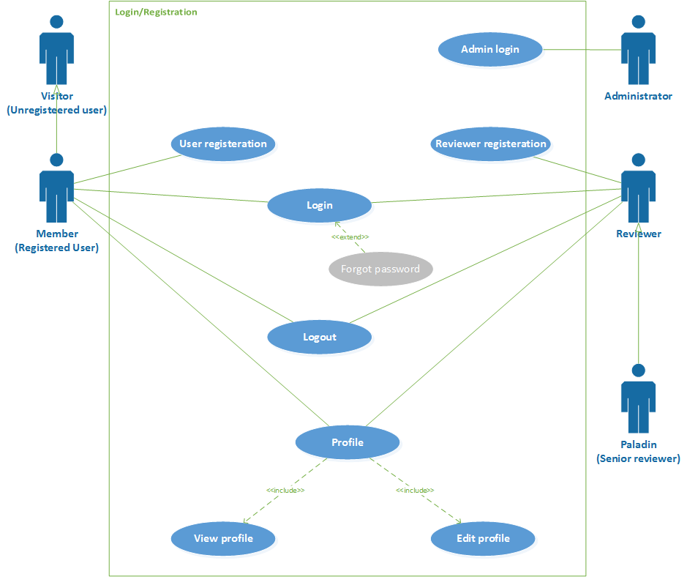

Figure 1: ReviewHub Usecase 1

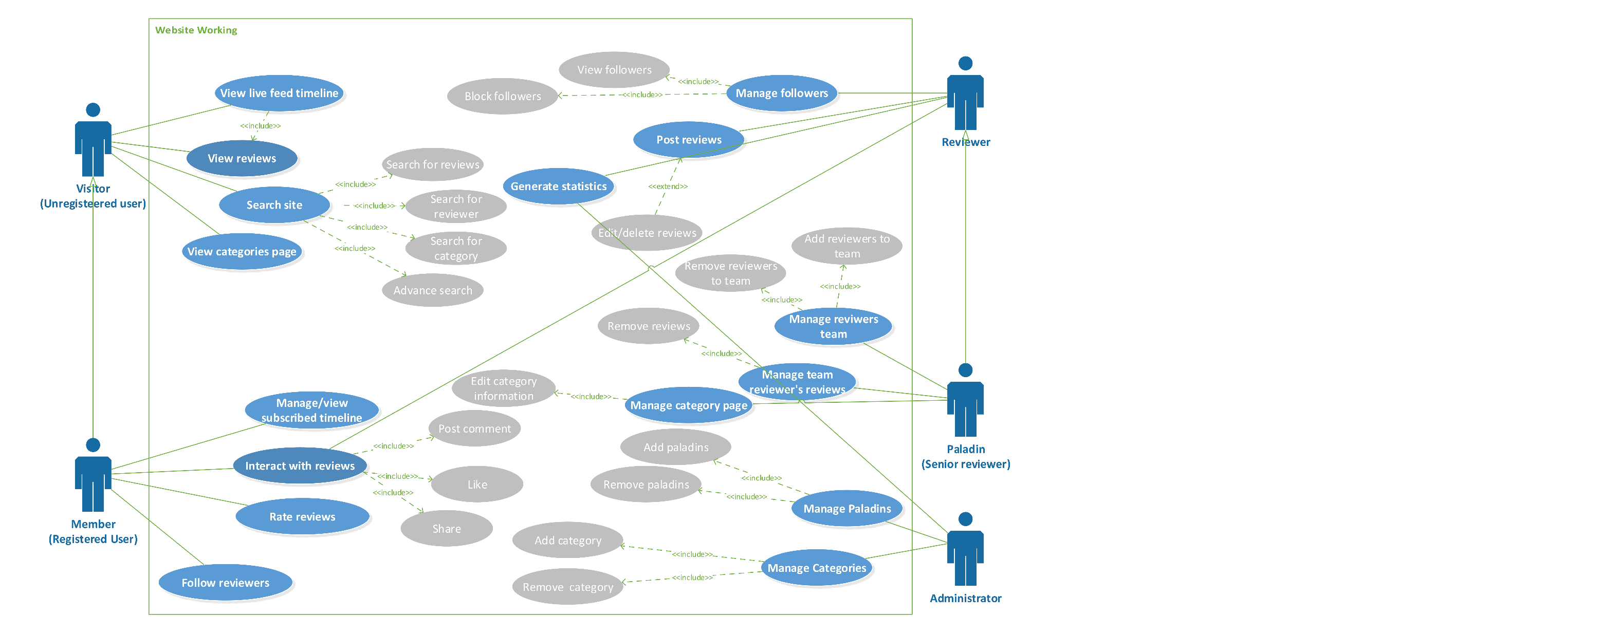

Figure 2: ReviewHub Usecase 2

## Use case descriptions

Below are the detailed working of primary and complex use cases*.*

### Registration

|  |  |  |  |
| --- | --- | --- | --- |
| **Use case ID: 001 Use case Name: Registration** | | | |
| **Priority high** | | | |
| **Actors:** Member, Reviewer | | | |
| **Use Case Summary** | Registration allows the Members and Reviewer to register to the website. | | |
| **Pre-condition:** | They have valid email ids or social media account | | |
| **Normal Course of Events** | | | **Alternate Path** |
| 1. The Use case starts when the Member/Reviewer comes to the website. | | |  |
| 1. The Member/Reviewer will select Register link to register. | | |  |
| 1. A form will open where the user will enter a unique username and proceed by clicking next | | | 3(a) A person can do registration by selecting Facebook or Gmail account instead |
| 1. A form will be opened to enter basic information such as password, email and date of birth | | |  |
| 1. On pressing Submit button, email will be sent for verification | | |  |
| 1. The user will click the verification link from mail | | |  |
| 1. If the verification link is working and not expired, user is redirected to website and is successfully registered | | | 7(a) If verification link is expired or broken, the link will be regenerated and resent to the user email |
| **Post Conditions** | | | |
| The Member/Reviewer will successfully be registered to website. | | | |
| **Use Case Cross References** | | | |
| **Includes** | | None | |
| **Extends** | | None | |
| **Exceptions** | | | |
| **2a.** If the Member/Reviewer is not verified he/she will not be registered. | | | |

Table 3: Use case description 1 – Registration

### Login

|  |  |  |  |
| --- | --- | --- | --- |
| **Use case ID: 002 Use case Name: Login** | | | |
| **Priority high** | | | |
| **Actors:** Admin, Member, Reviewer | | | |
| **Use Case Summary** | Login allows the Admin, Member and Reviewer to Login to their account on the website. | | |
| **Pre-condition:** | They are already registered to the website. | | |
| **Normal Course of Events** | | | **Alternate Path** |
| 1. The use case starts when the user opens the website. | | |  |
| 1. The user will click the login link | | |  |
| 1. In the form opened, the user will provide the username or email and password to his account | | |  |
| 1. On pressing login button the user will be logged in to the website. | | | 4(a) if the details are incorrect, the user will fail to login and will be asked to re-enter correct details |
|  | | |  |
| **Post Conditions** | | | |
| The Admin/Reviewer/Member will successfully be logged in to website. | | | |
| **Use Case Cross References** | | | |
| **Includes** | | None | |
| **Extends** | | Forgot password | |
| **Exceptions** | | | |
| **2a.** If the user is not registered he will not be logged in | | | |

Table 4: Use case description 2 – Login

### Manage Profile

|  |  |  |  |
| --- | --- | --- | --- |
| **Use case ID: 003 Use case Name: Manage Profile** | | | |
| **Priority medium** | | | |
| **Actors:** Reviewer, Member | | | |
| **Use Case Summary** | Manage profile allows the Reviewer and Member to view, add and update their profile information. | | |
| **Pre-condition:** | They must have an account and logged in. | | |
| **Normal Course of Events** | | | **Alternate Path** |
| 1. The use case starts when the user opens the website. | | |  |
| 1. The reviewer and member will click on profile button | | |  |
| 1. A person can view profile with details such as name, profile picture, about information, follows, follower(in case of reviewers), review posts etc. | | |  |
| 1. The user will be able to update all above information by clicking ‘edit profile’ button | | |  |
| 1. On pressing save button user will see the message "Profile successfully updated". | | | 5(a) Putting erroneous information will result in not updating any field in the prolife and a message will be displayed “Profile not updated” |
| **Post Conditions** | | | |
| The Reviewer/Member will successfully view/updated profile | | | |
| **Use Case Cross References** | | | |
| **Includes** | | View profile, edit profile | |
| **Extends** | | None | |
| **Exceptions** | | | |
|  | | | |

Table 5: Use case description 3 - Manage profile

### View Review

|  |  |  |  |
| --- | --- | --- | --- |
| **Use case ID: 004 Use case Name: View Review** | | | |
| **Priority high** | | | |
| **Actors:** Member, Visitor | | | |
| **Use Case Summary** | View review allows the Member/Visitor to view the detail review post on the website. | | |
| **Pre-condition:** | User is logged in to the website. | | |
| **Normal Course of Events** | | | **Alternate Path** |
| 1. The use case starts with user visiting the website | | |  |
| 1. The user is either viewing the timeline or searches for a review | | |  |
| 1. The user will then click review to open detailed review | | |  |
|  | | |  |
| **Post Conditions** | | | |
| The Visitor/Member will successfully be shown with the detailed review post | | | |
| **Use Case Cross References** | | | |
| **Includes** | | None | |
| **Extends** | | None | |
| **Exceptions** | | | |
|  | | | |

Table 6: Use case description 4 - View review

### Search

|  |  |  |  |
| --- | --- | --- | --- |
| **Use case ID: 005 Use case Name: Search** | | | |
| **Priority medium** | | | |
| **Actors:** Visitor, Member | | | |
| **Use Case Summary** | Search for review, reviewer or category on website. | | |
| **Pre-condition:** | User should be on website | | |
| **Normal Course of Events** | | | **Alternate Path** |
| 1. The use case starts when the user is on home page | | |  |
| 1. The user will type a specific keyword or line and search | | | 2(a )The user can click advance search and apply filters to generate specific results |
| 1. Results will be displayed from reviews, reviewers or category | | |  |
|  | | |  |
| **Post Conditions** | | | |
| The user will successfully use search feature to generate list of search result. | | | |
| **Use Case Cross References** | | | |
| **Includes** | | Search for reviews, search for reviewer, search for category, advance search | |
| **Extends** | | None | |
| **Exceptions** | | | |
|  | | | |

Table 7: Use case description 5 - Search

### Interact with Review

|  |  |  |  |
| --- | --- | --- | --- |
| **Use case ID: 006 Use case Name: Interact with review** | | | |
| **Priority high** | | | |
| **Actors:**  Member, Reviewer, Paladin | | | |
| **Use Case Summary** | The user can interact with the reviews posted by comment like and share | | |
| **Pre-condition:** | The user must be logged in | | |
| **Normal Course of Events** | | | **Alternate Path** |
| 1. The use case starts when the user opens the detailed review | | |  |
| 1. The user can then either comment below the review or like or share the review | | |  |
|  | | |  |
| **Post Conditions** | | | |
| The user will successfully do either of the activities | | | |
| **Use Case Cross References** | | | |
| **Includes** | | Like, post comment, share | |
| **Extends** | | None | |
| **Exceptions** | |  | |

Table 8: Use case description 6 - Interact with review

### Manage Followers

|  |  |  |  |
| --- | --- | --- | --- |
| **Use case ID: 007 Use case Name: Manage followers** | | | |
| **Priority medium** | | | |
| **Actors:**  Reviewer, Paladin | | | |
| **Use Case Summary** | The reviewer/paladin will manage the followers | | |
| **Pre-condition:** | The reviewer/paladin should be logged in | | |
| **Normal Course of Events** | | | **Alternate Path** |
| 1. The use case starts with user being on profile page | | |  |
| 1. The user clicks on followers list | | |  |
| 1. The user can see all the members on the website who are following him/her | | | 3(a) The user can also select a specific member of the site and block him/her |
|  | | |  |
| **Post Conditions** | | | |
| The list of followers will be populated and/or a specific member will be blocked | | | |
| **Use Case Cross References** | | | |
| **Includes** | | View followers, Block followers | |
| **Extends** | | None | |
| **Exceptions** | | None | |

Table 9: Use case description 7 - Manage followers

### Post Review

|  |  |  |  |
| --- | --- | --- | --- |
| **Use case ID: 008 Use case Name: Post review** | | | |
| **Priority high** | | | |
| **Actors:**  Reviewer, Paladin | | | |
| **Use Case Summary** | Reviewer/Paladin will post a review on the site | | |
| **Pre-condition:** | Reviewer/Paladin is logged in | | |
| **Normal Course of Events** | | | **Alternate Path** |
| 1. The use case starts when user clicks the new review button | | |  |
| 1. Then the user is required to fill the post format and add the details of the product like name, description, category, price, photo etc. | | |  |
| 1. The user then enters rating stars | | |  |
| 1. The user will then post the review by pressing Post button | | | 4(a) The user can also edit/delete the review after posting |
| **Post Conditions** | | | |
| The new product review will be posted | | | |
| **Use Case Cross References** | | | |
| **Includes** | | Edit post, Delete post | |
| **Extends** | | None | |
| **Exceptions** | | None | |

Table 10: Use case description 8 - Post review

### Logout

|  |  |  |  |
| --- | --- | --- | --- |
| **Use case ID: 009 Use case Name: Logout** | | | |
| **Priority high** | | | |
| **Actors:** Member, Reviewer, Admin | | | |
| **Use Case Summary** | Logout allows Member/Reviewer/Admin to logout from the website | | |
| **Pre-condition:** | They are already Logged in to the website. | | |
| **Normal Course of Events** | | | **Alternate Path** |
| 1. The Use case starts when the user wants to logout of the website | | |  |
| 1. The user will click on the logout link on the website | | |  |
| 1. He will successfully be logged out from website | | |  |
| **Post Conditions** | | | |
| The Member/Reviewer/Admin will successfully logged out | | | |
| **Use Case Cross References** | | | |
| **Includes** | | None | |
| **Extends** | | None | |
| **Exceptions** | | | |
|  | | | |

Table 11: Use case description 9 - Logout

## Software development life cycle model

This section holds development life cycle being used along with it being justified

**Agile software development and Rapid application development (RAD)**

We are going to use a mix of agile software development with Rapid Prototyping. Agile software development is used when the requirements are on a constant developing stage and while pretty much technology is understood. Whereas, Rapid Prototyping model is used where emphasize is made based on adapting to change in requirement in response to knowledge gained as the project progresses.

### Justification

Due to on-the-run development and no detailed documentation or functionality workflow previously available and/or followed, agile software development was used to work and produce the project in short incremental approach and adding short functionalities in each iteration to provide a working product.

Further on RAD approach is used to as the risk was accumulated to be fairly less and to make the project flexible to requirement and less formality in documentation and procedure. RAD’s approach of prototyping is adopted to constantly to refine project in terms of front-end requirement gathering. Also using the approach tools for auto generation of codes was to be used.

A slight flavour of new approach of DevOps was used in this project using some of its techniques such as version controlling etc.

# System Design

Section contains multiple designs of the website’s working.

## Architecture Diagram

A configuration defining basic structure and behaviour of the website and system.



Figure 3: ReviewHub Architecture Diagram

Application is web based so we the architectural style will be web based architecture.

First user will connect to the internet and enter the URL of the web application. The apache running on the webserver will cater the request and send back the requested page/file/images. However, if some of the API’s or services have to be used then services will be called from third party server or application server.

There will be MySQL database running on the database server so that records could be stored and fetched when needed by the application or user.

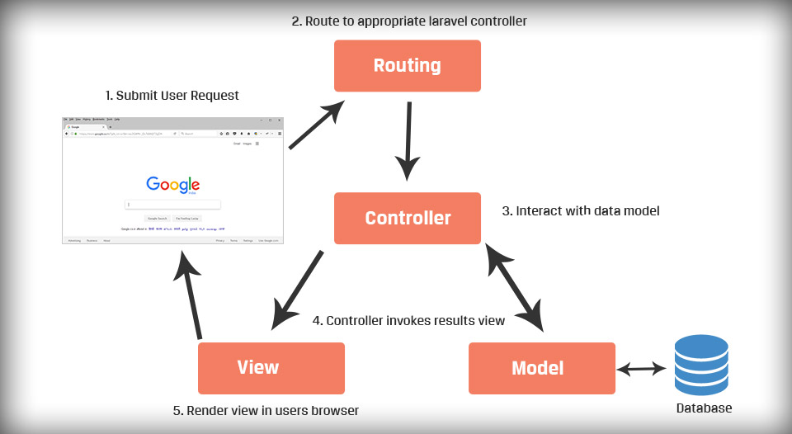

Figure 4: MVC Architecture Diagram

The technology used on the project a php framework Laravel which is based on MVC framework architecture.

## Work Breakdown Structure (WBS)

The following Work Breakdown Structure will be followed throughout the project.

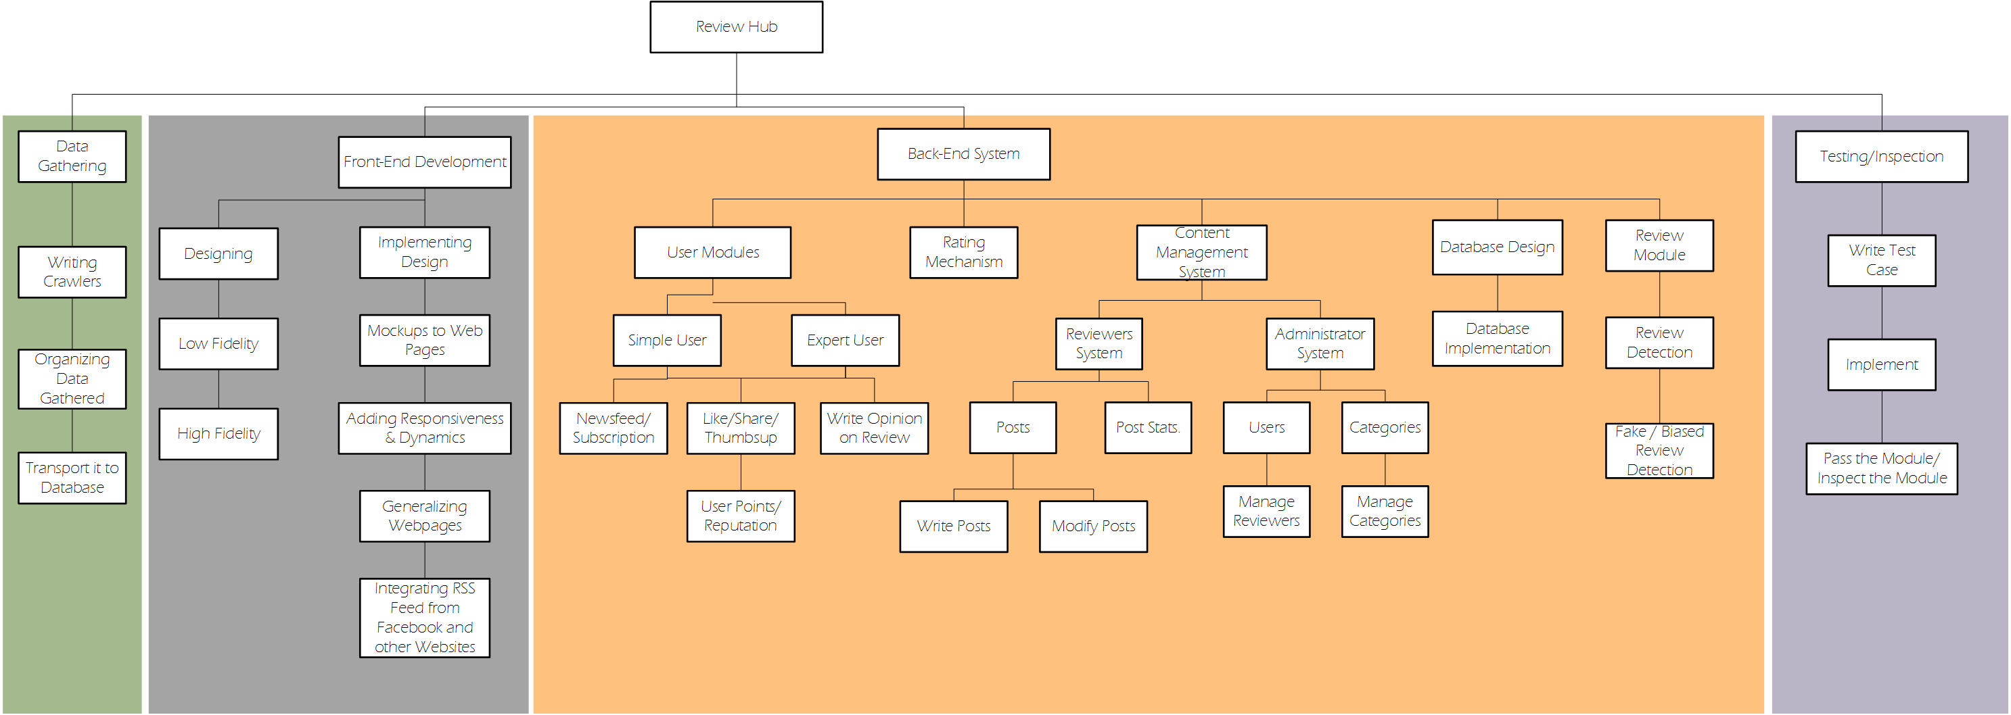

Figure 5: ReviewHub WBS

## Activity diagram

The following diagrams represent the basic flow of multiple activities on the website.

### User Sign In + Sign Up

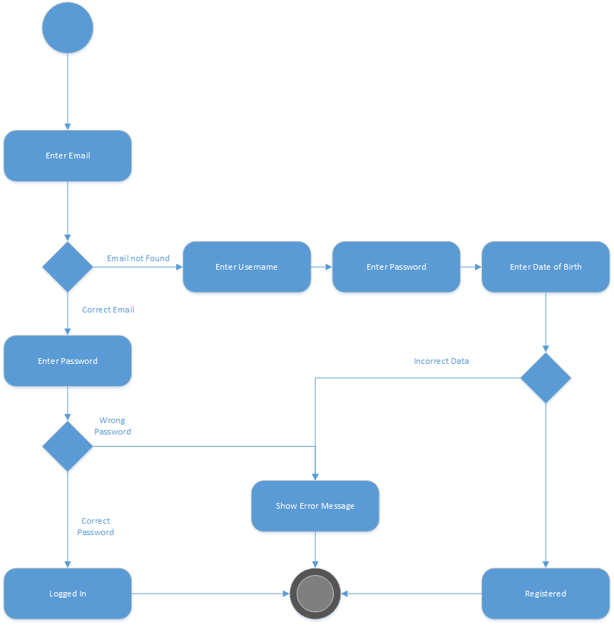

Figure 6: Sign in/Signup Activity

### Newsfeed

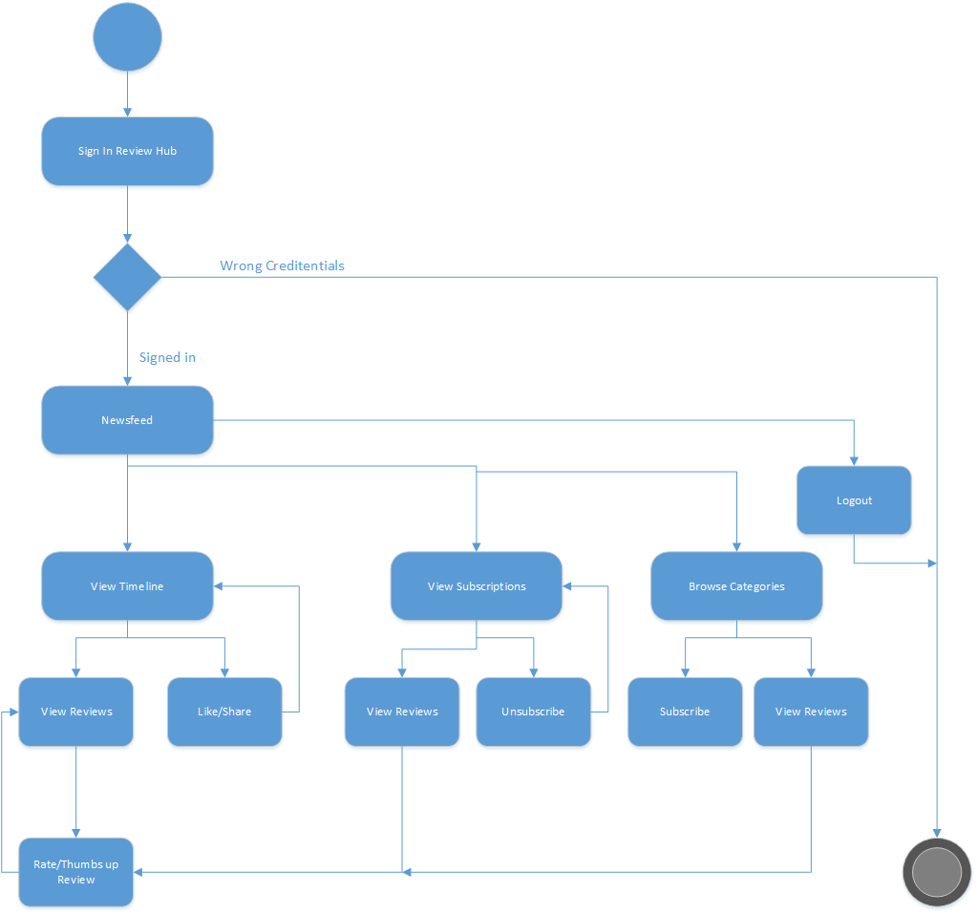

Figure 7: Newsfeed Activity

### Create Review

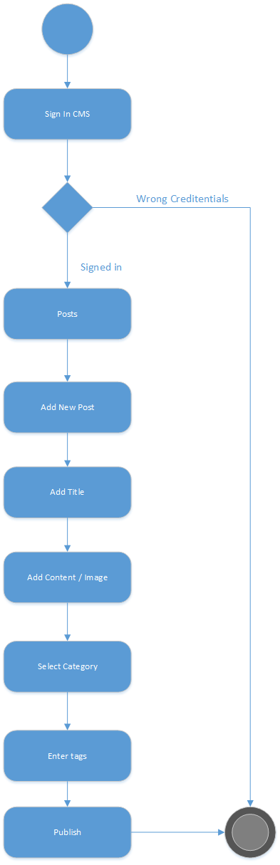

Figure 8: Create Review Activity

### CMS Login

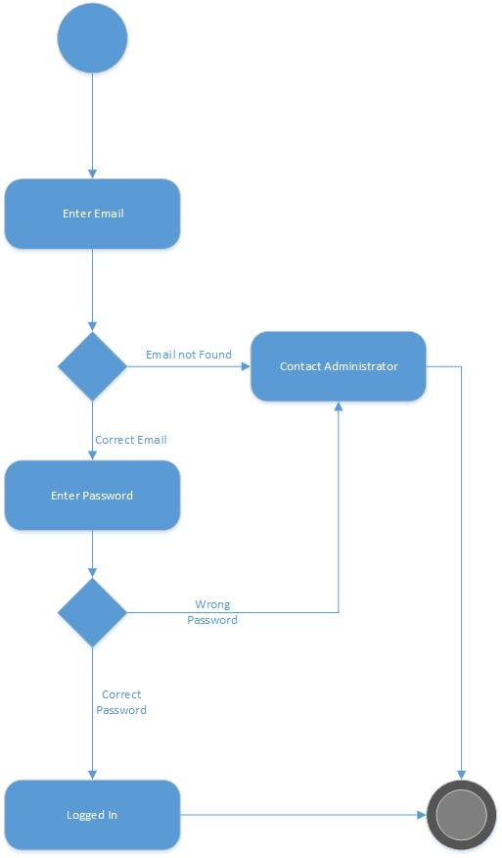

Figure 9: CMS Login Activity

## Sequence diagram

The following diagrams represent the sequence of action of multiple activities.

### Member Login/Register

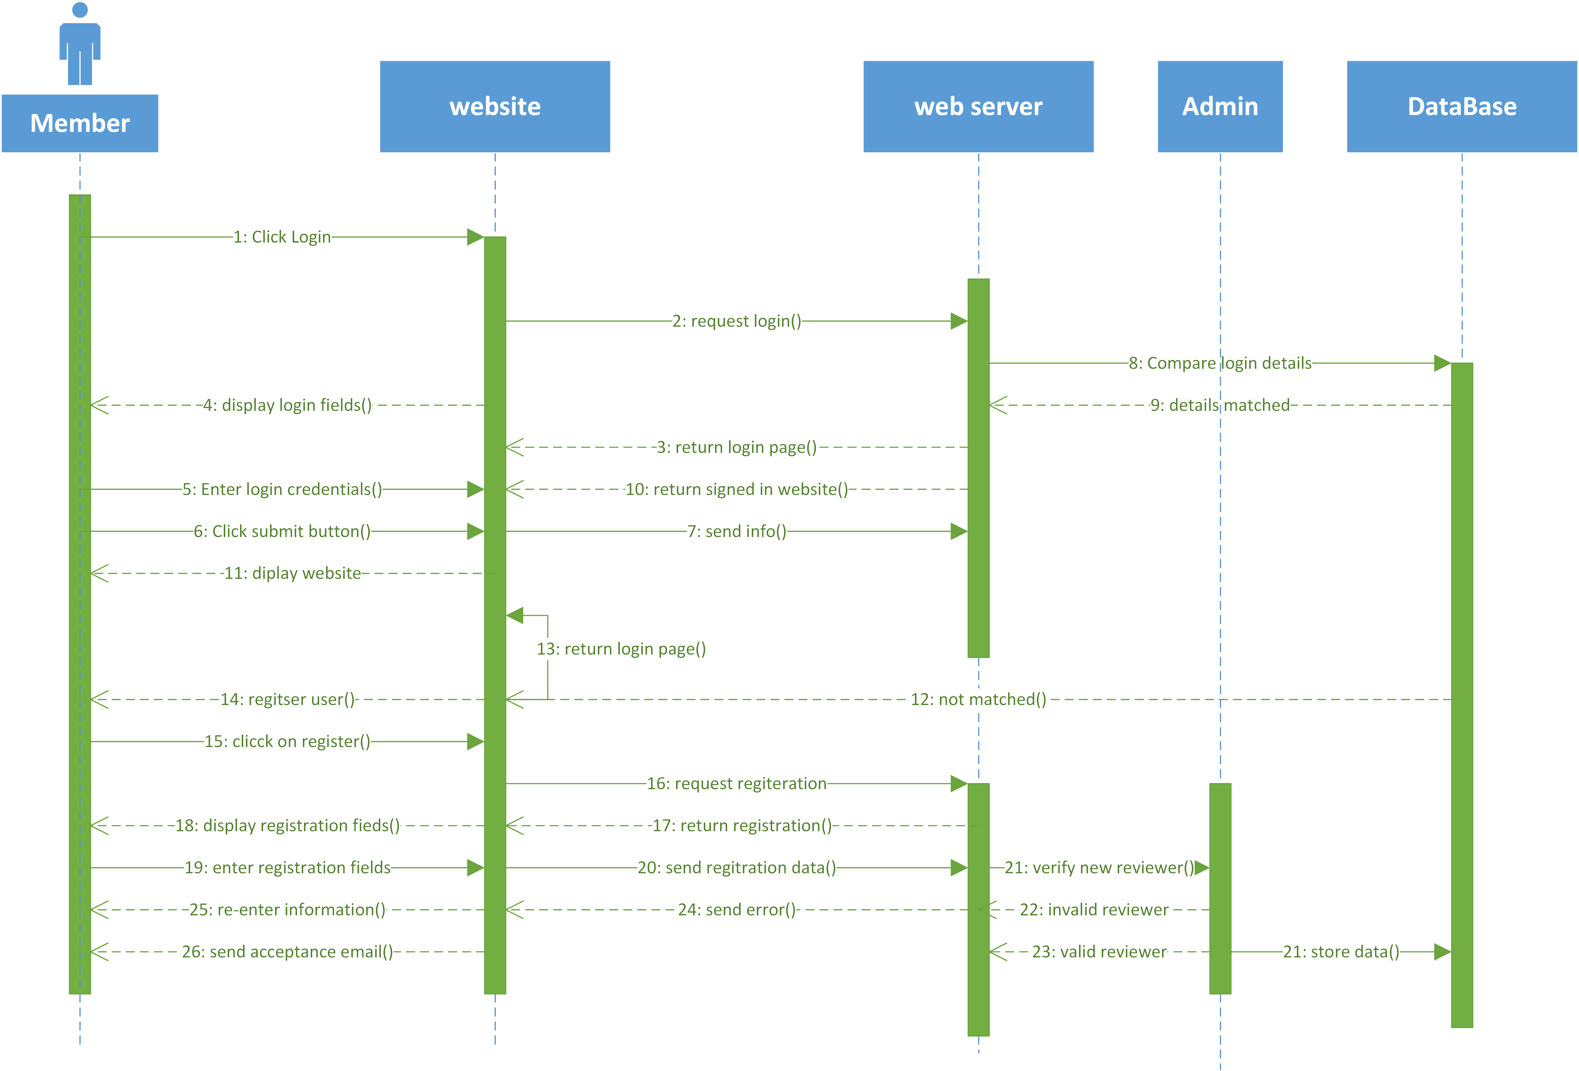

Figure 10: Member Login/Register Sequence diagram

### Reviewer Login

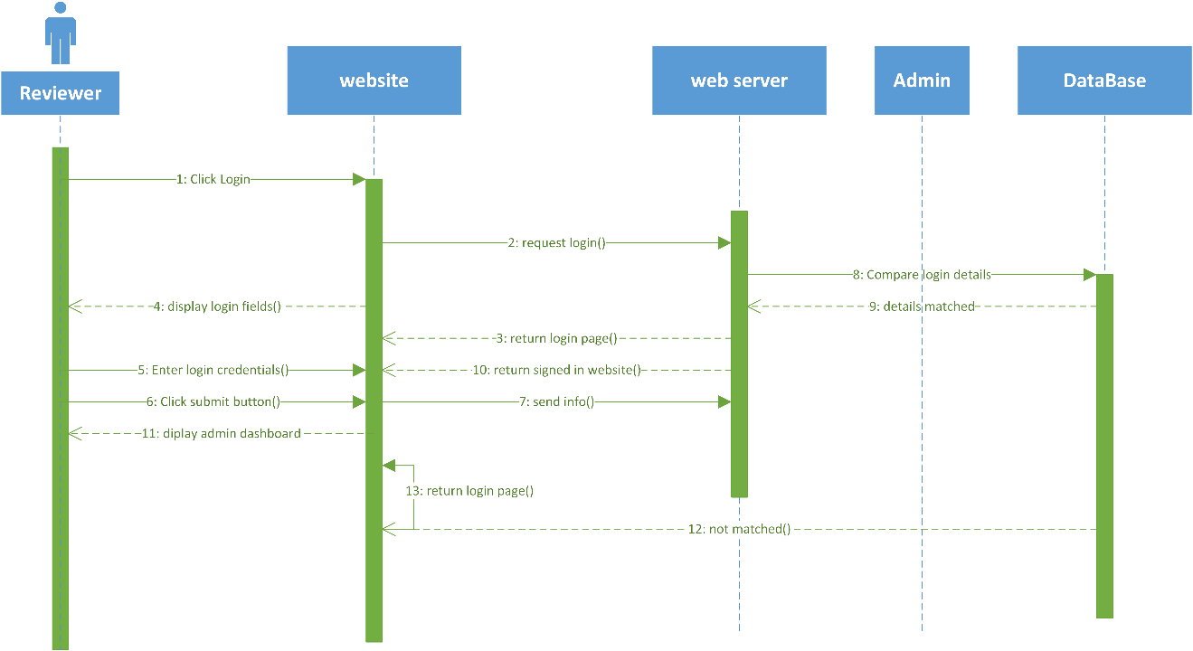

Figure 11: Reviewer Login Sequence diagram

### Reviewer Register

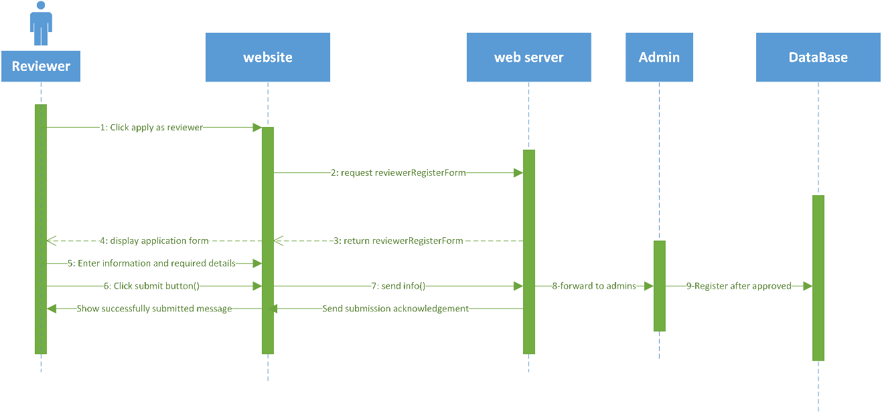

Figure 12: Reviewer Register Sequence diagram

### Visitor

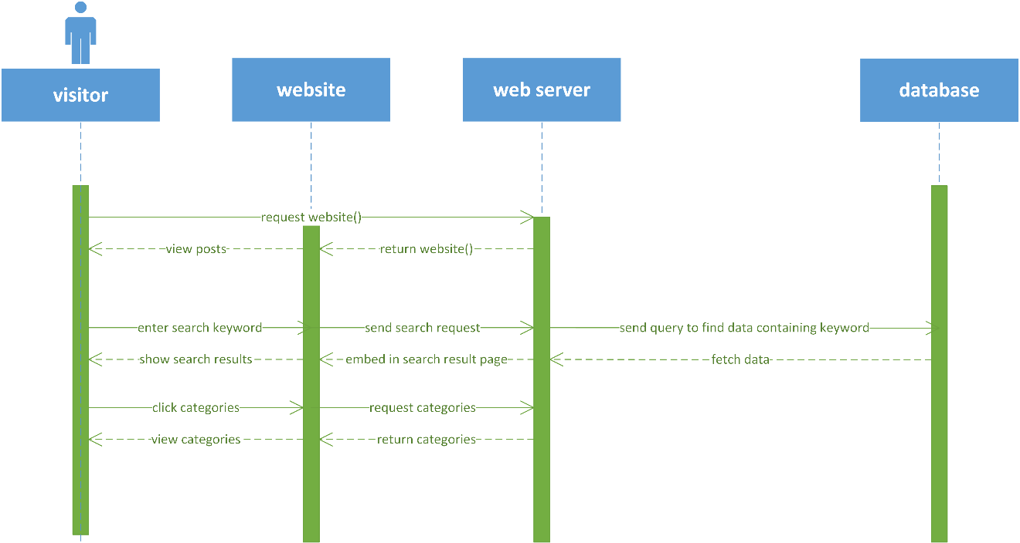

Figure 13: Visitor Actions Sequence diagram

### Member

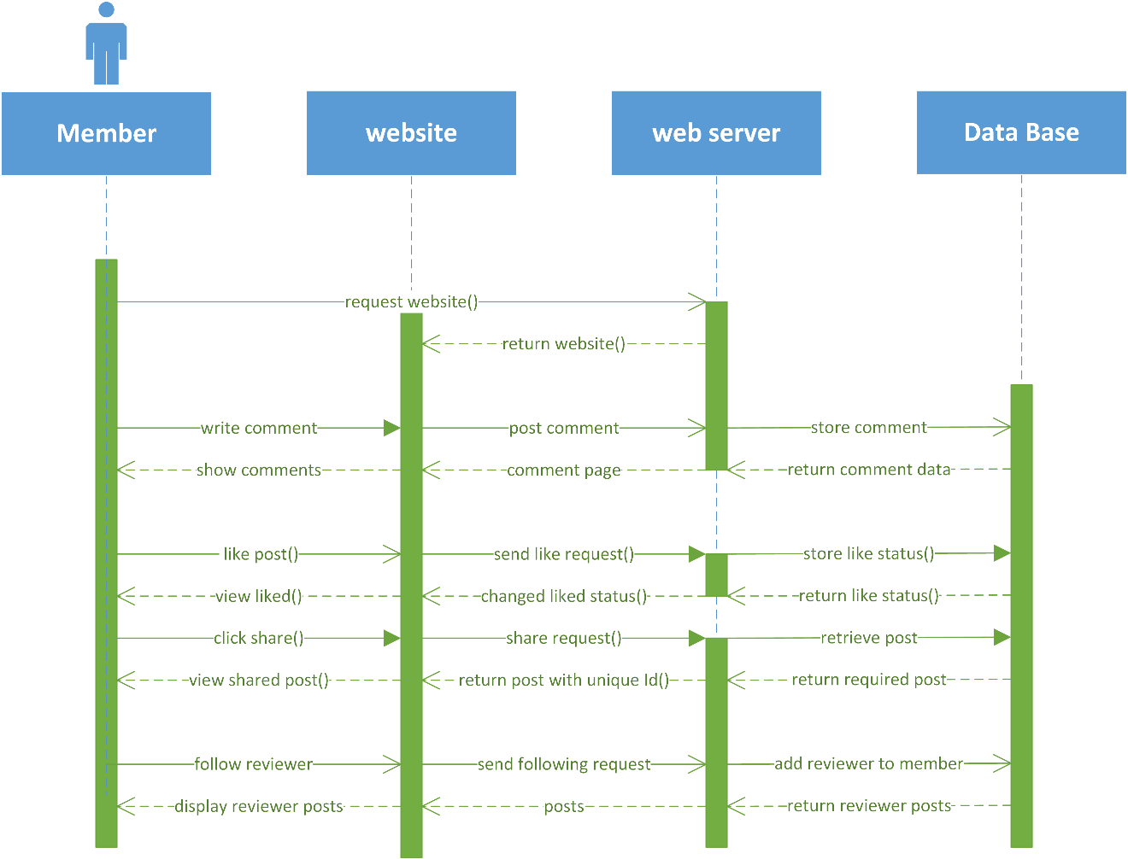

Figure 14: Member Actions Sequence diagram

### Reviewer

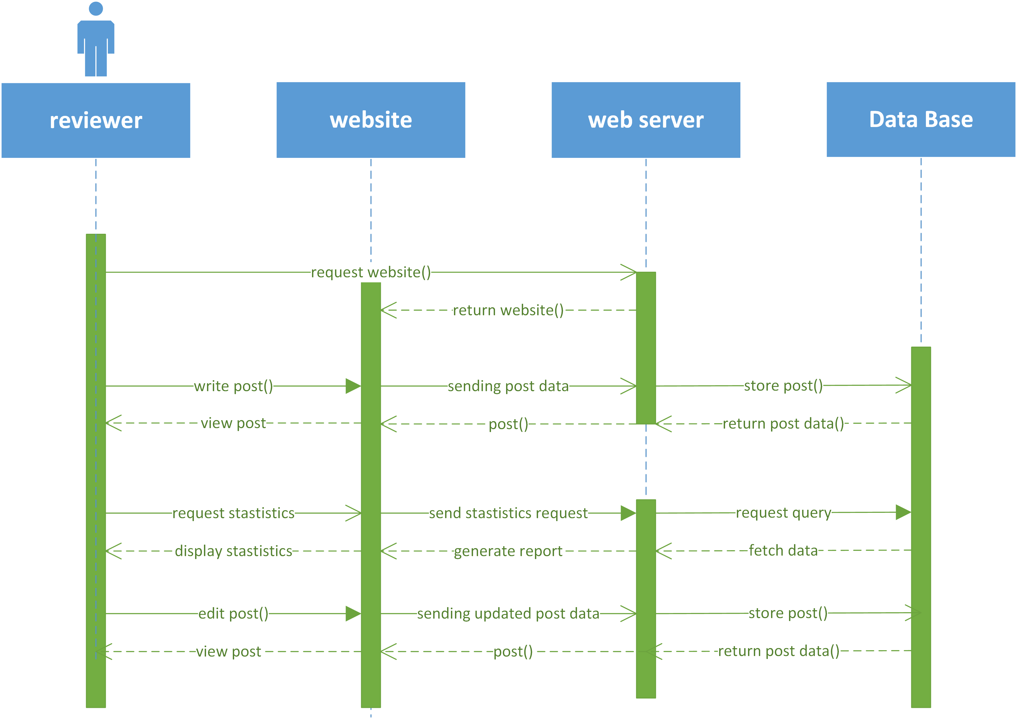

Figure 15: Reviewer Actions Sequence diagram

## Database Design

A model of the database for the web app.



Figure 16: ERD

## Gantt chart

Chart given below will be followed for tentative resources and scheduling.

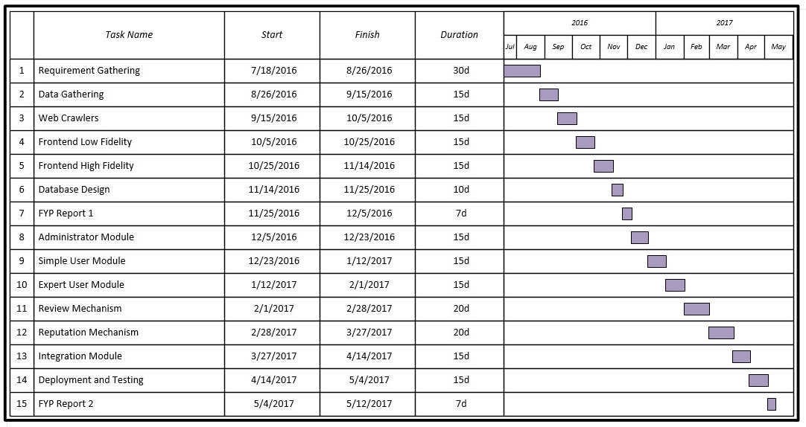

Figure 17: Gantt chart

### Gant chart task description

The table below is the task achieved/to-do by members

Table 12: Gant chart task description

|  |  |
| --- | --- |
| Member | Tasks/Development Area |
| Talal Mirza | Front-end high fidelity diagrams |
| Database Design |
| Database implementation |
| ERD |
| Documentation |
| Documentation formatting |
| Backend development: Models, Relations, Controllers |
| Poster Designing |
|  |  |
| Humza Waseem | Logo and Vector Graphics Designing |
| Front end development |
| Blade templating |
| Dynamic content implementation : AJAX |
| Documentation |
| Report diagrams |
| Backend development: Models, Controllers |
| Poster Designing |
|  |  |
| Ali Haider | Front end development |
| Documentation |
| Report diagrams |
| Literature review and support materials |
| Backend development: Models, Controllers |
| Poster Designing |

## Interface design

The following is the beta version of high fidelity diagram implementation

### Splash Page

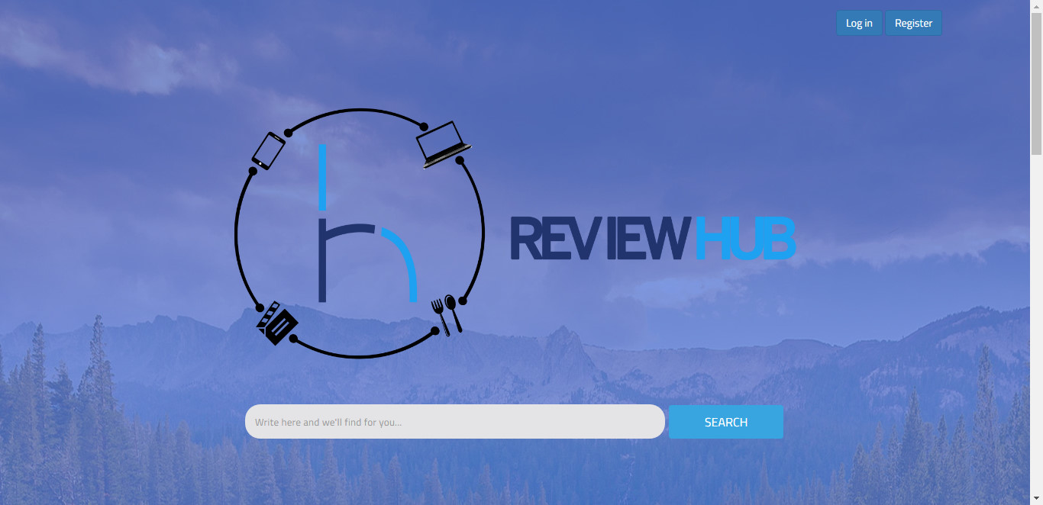

Figure 18: Splash Page 1 HF

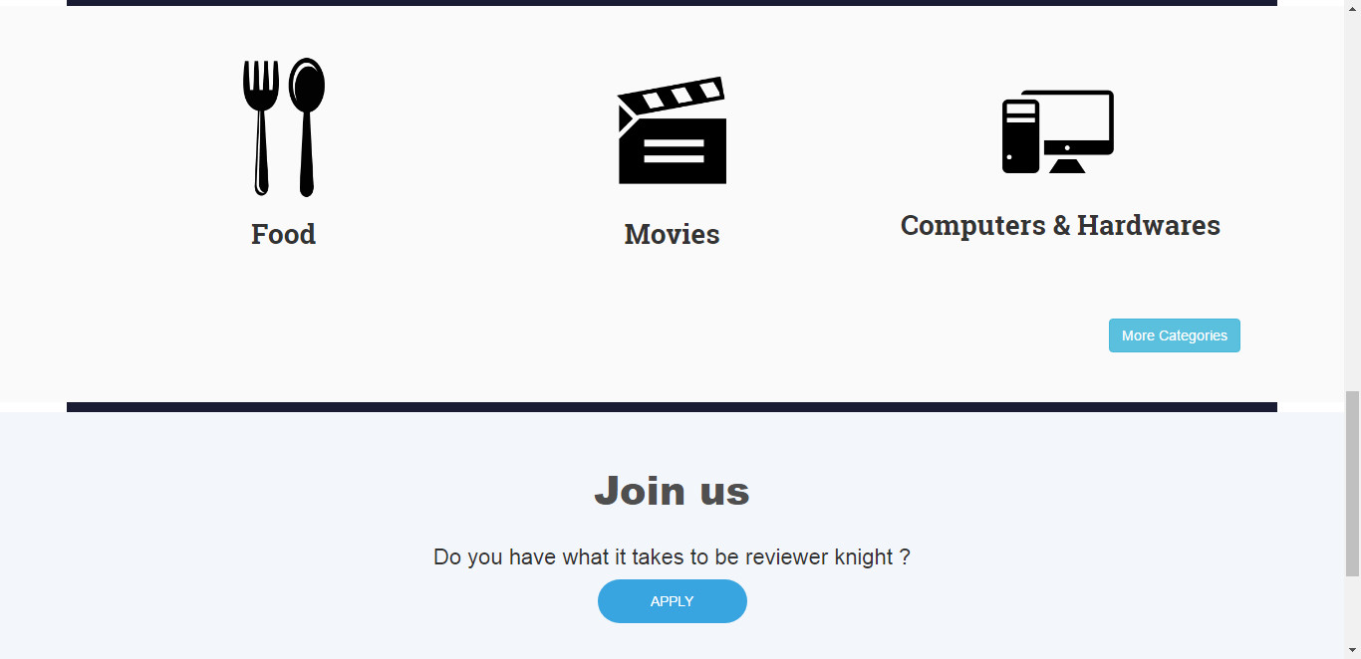

Figure 19: Splash Page 2 HF

### Contact Us

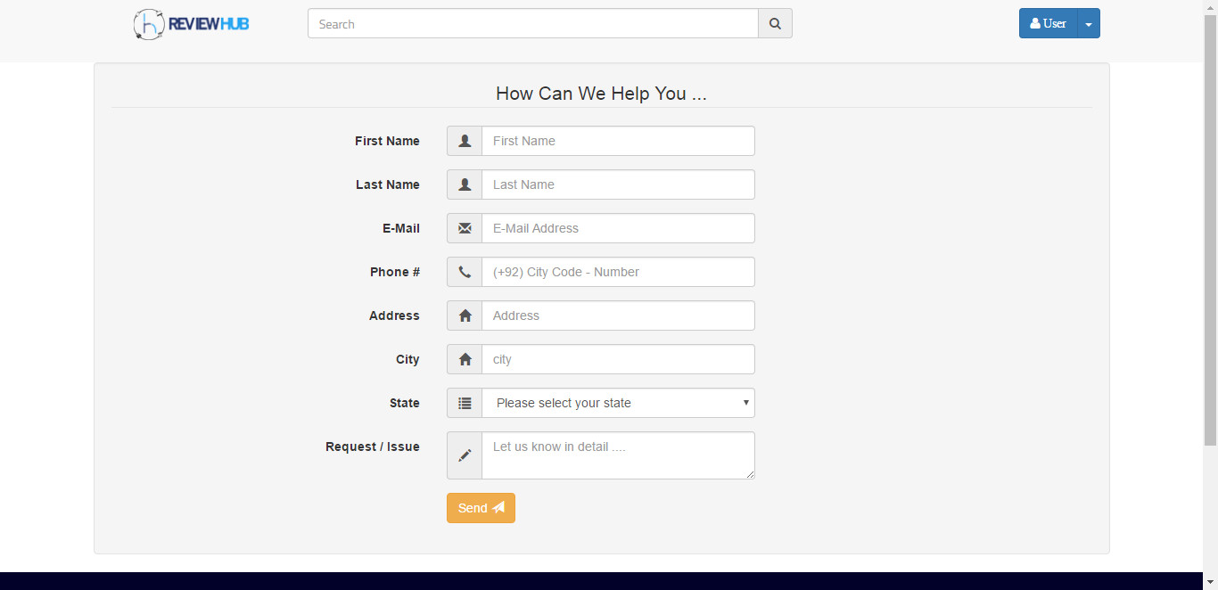

Figure 20: Contact Us HF

### Member Login

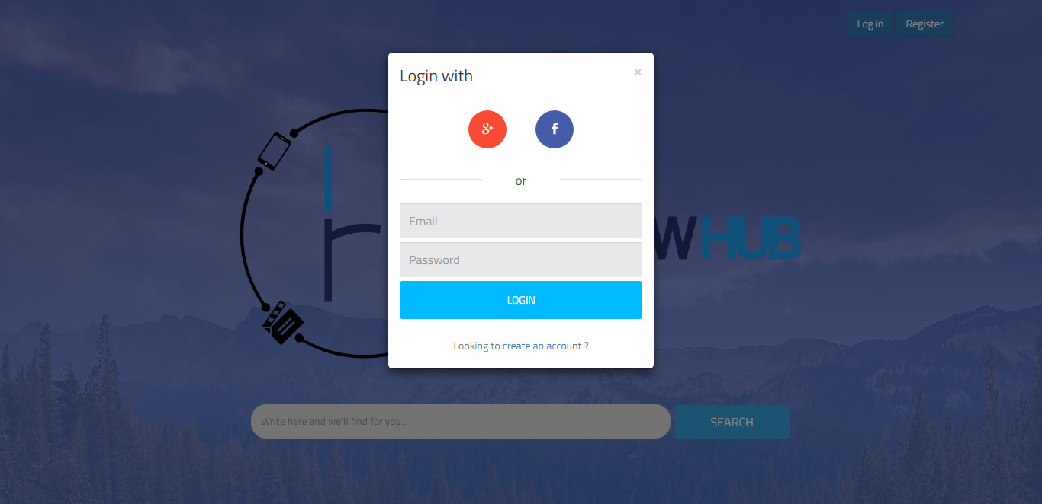

Figure 21: Member Login HF

### Member Register

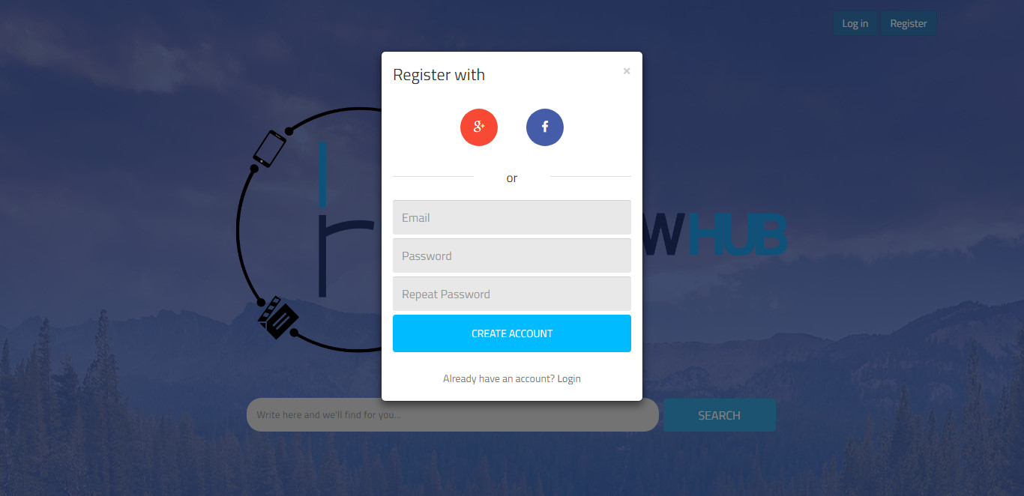

Figure 22: Member Register HF

### Home Page

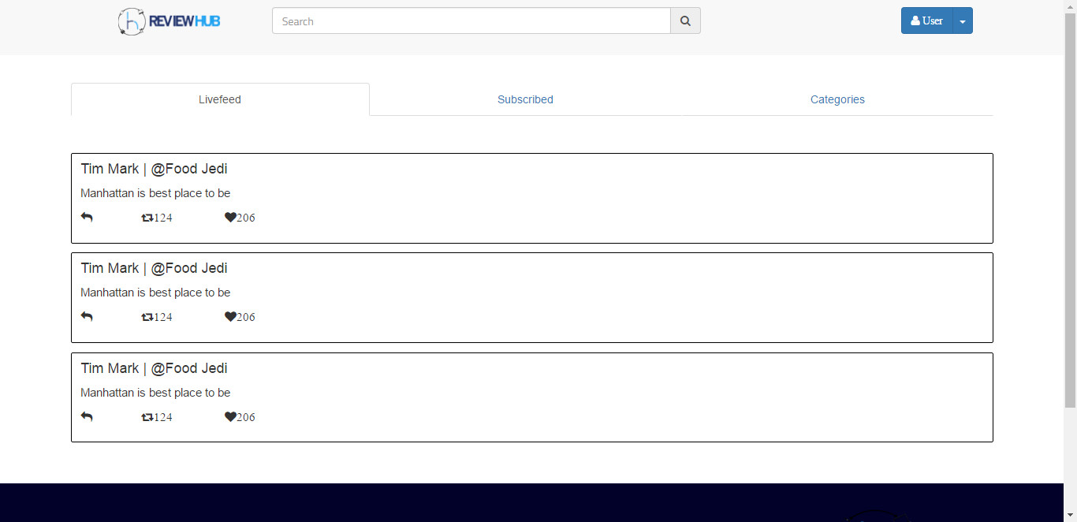

Figure 23: Home Page Live Feed HF

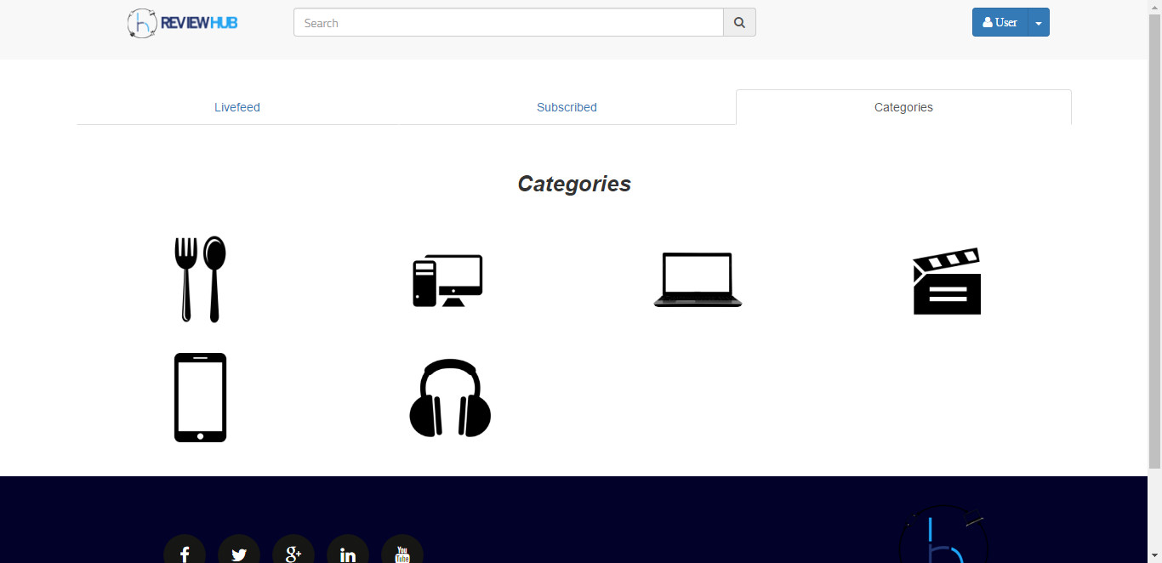

Figure 24: Home Page_Categories HF

### View/Edit profile

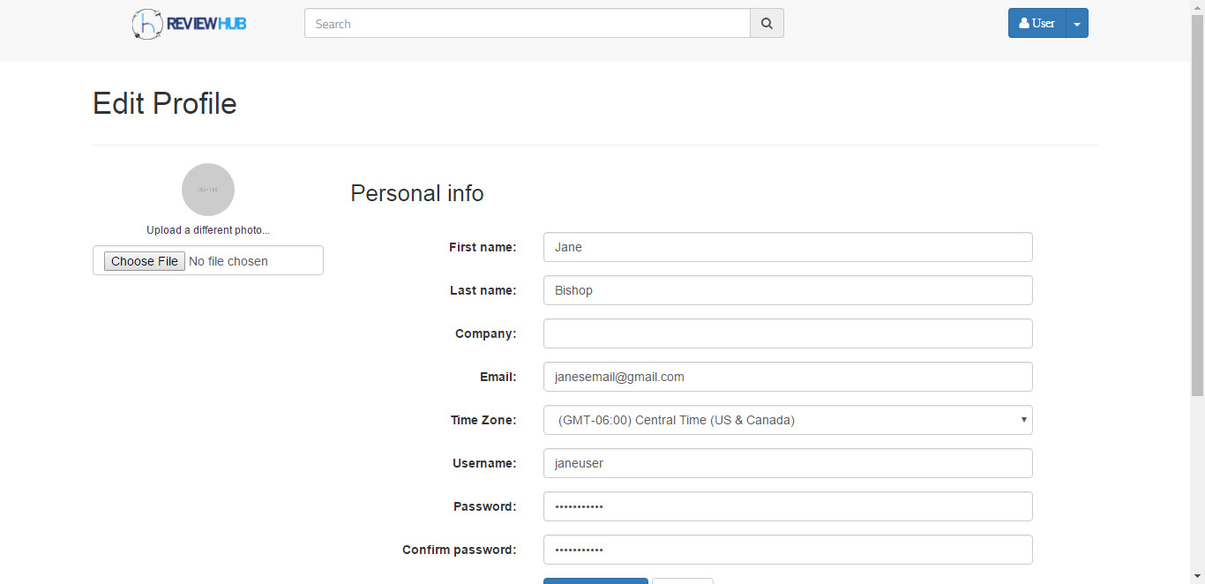

Figure 25: Member Profile Edit 1 HF

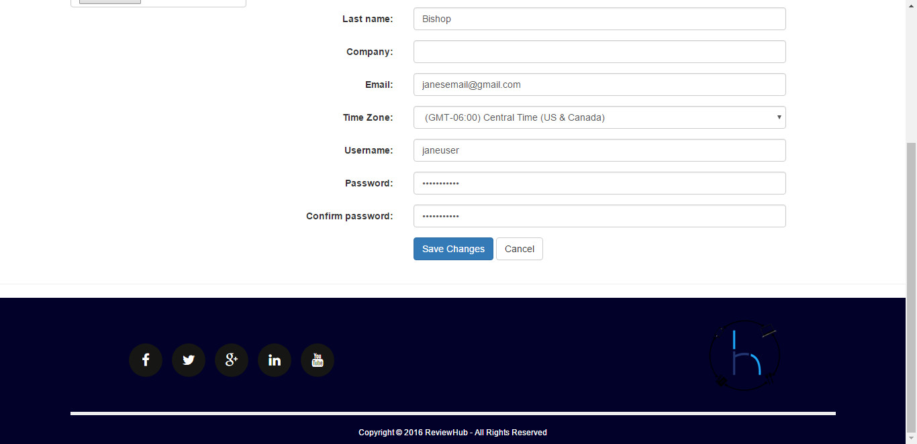

Figure 26: Member Profile Edit 2 HF

### Admin Login

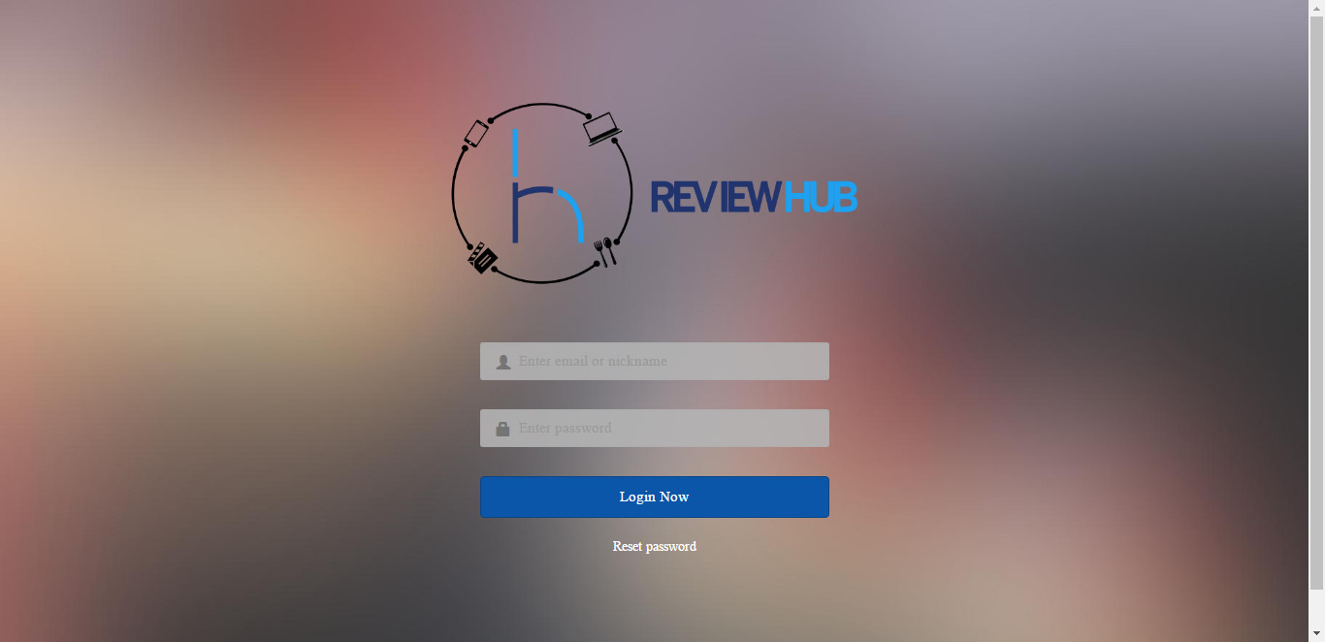

Figure 27: Admin Login HF

### Admin Panel Home

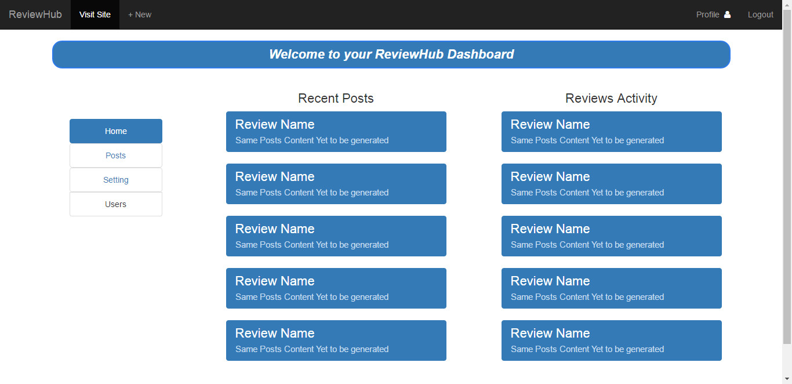

Figure 28: Admin Panel_Home HF

### Admin Panel Posts

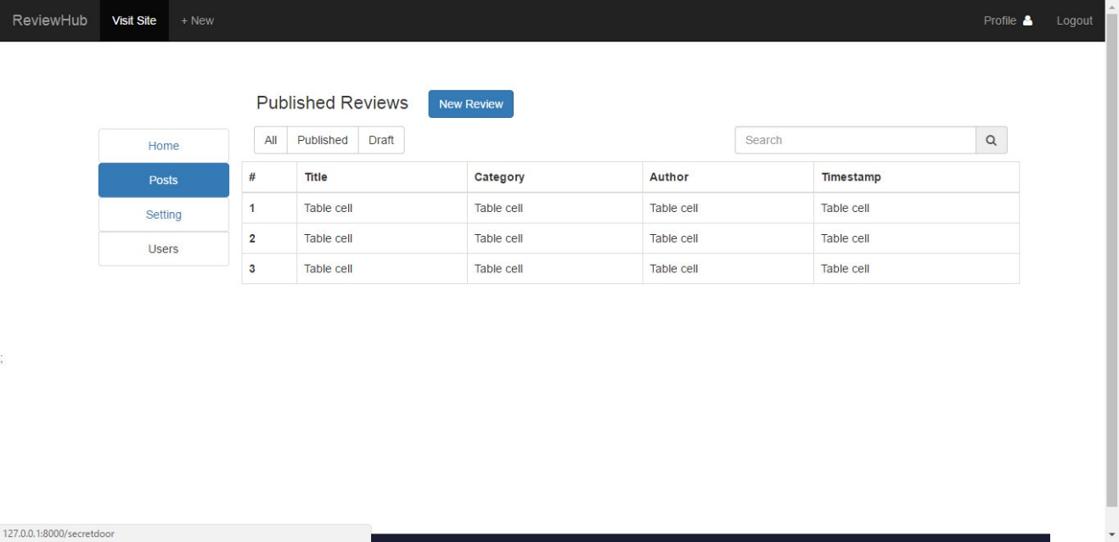

Figure 29: Admin Panel_Posts HF

### Admin Panel

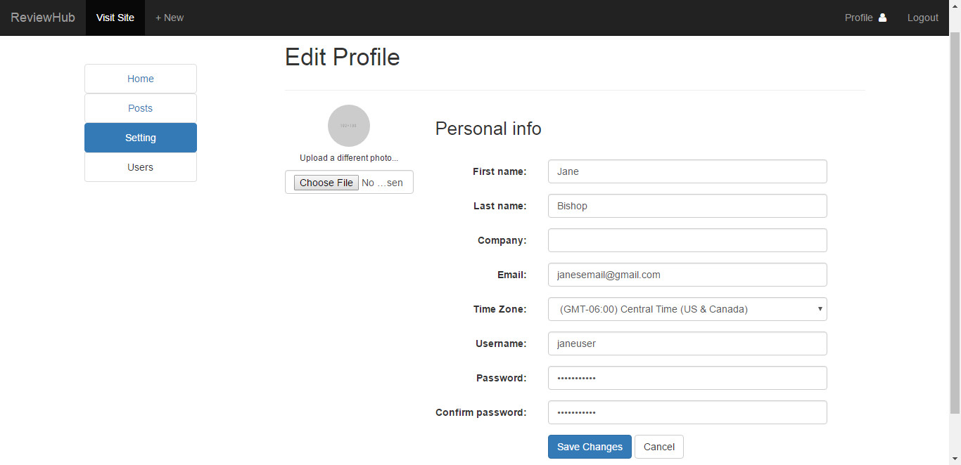

Figure 30: Admin Panel_Settings HF

# System Testing

This section holds the test cases made for the web application

## Test cases

### Test Case 1.1

**Description:** Splash Page

**Pre-Condition(s):** Splash Page should be live and rendered completely.

**Post-Conditions(s):** Featured article post would be opened / Search Results displayed

|  |  |  |
| --- | --- | --- |
| **Step** | **Action Performed** | **System Response** |
| 1 | Launch URL | Website should open and render. |
| 2 | Click featured article | Article link should open and display review |
| 3 | Click like button | Review should be liked |
| 4 | Click share button | Share by FB, Email etc. option displayed |
| 5 | Search specific keyword | Search results page should be displayed. |

Table 13: Test case 1 - Splash page

### Test Case 2.1

**Description:** Register Popup

**Pre-Condition(s):** User should have valid email address and should be on splash page.

**Post-Conditions(s):** User should be redirected to home page after successful registration.

|  |  |  |
| --- | --- | --- |
| **Step** | **Action Performed** | **System Response** |
| 1 | Click register button. | Register popup will open. |
| 2 | Enter valid email | It will check if the email already is registered, if so it will notify the user and redirect to login popup. If not it will proceed with registration process. |
| 3 | Enter valid password | Password will be entered in the form of dots to ensure privacy. |
| 4 | Enter password again to verify | If both the entered password are same, user will be allowed to proceed. |
| 5 | Click Register | User will be redirected to homepage along with Welcome Message. |
| 6 | Register using Facebook/Google | User will be asked to grant access to Facebook or Google to fetch necessary data for registration. |

Table 14: Test case 2 - Register Popup

### Test Case 3.1

**Description:** Login Popup

**Pre-Condition(s):** User should have registered email address and should be on splash page.

**Post-Conditions(s):** User should be redirected to home page after successful registration.

|  |  |  |
| --- | --- | --- |
| **Step** | **Action Performed** | **System Response** |
| 1 | Click login button. | Login popup will open. |
| 2 | Enter valid email | It will check if the email already is registered, if yes it will ask user to enter the password. If not the user will be redirected to register popup. |
| 3 | Enter valid password | Password will be entered in the form of dots to ensure privacy. |
| 4 | Click login button | The user will be logged in to the application and redirected to homepage. |
| 5 | Login using Facebook/Google | User will be asked to grant access to Facebook or Google to fetch necessary data for login into the application. |

Table 15: Test case 3 - Login Popup

### Test Case 4.1

**Description:** Profile Page

**Pre-Condition(s):** User should be registered member and home page is opened.

**Post-Conditions(s):** User profile should be updated to the newly updated information.

|  |  |  |
| --- | --- | --- |
| **Step** | **Action Performed** | **System Response** |
| 1 | Click profile button from navigation. | Profile page will open. |
| 2 | Modify/Update information | The previous input fields should be overwrite by new information. |
| 3 | Change/Upload profile avatar | The old profile picture is replaced by new uploaded one. |
| 4 | Click save changes button | The new information is updated in the records. |
| 5 | Click cancel button | All the unsaved changes are revert back to previous saved settings. |

Table 16: Test case 4 - Profile page

### Test Case 5.1

**Description:** Search

**Pre-Condition(s):** User should have Splash Page or Home Page opened.

**Post-Conditions(s):** Search results are shown for the specific keyword.

|  |  |  |
| --- | --- | --- |
| **Step** | **Action Performed** | **System Response** |
| 1 | Enter keyword to search. | The input field should be populated with the enter keyword or string. |
| 2 | Click Search | After processing, search results will be shown to user/member. |

Table 17: Test case 5 – Search

### Test Case 6.1

**Description:** Home Page

**Pre-Condition(s):** User should be registered member and home page is opened.

**Post-Conditions(s):** User profile should be able to interact with reviews. (Read/Comment/Like/Share/Subscribe)

|  |  |  |
| --- | --- | --- |
| **Step** | **Action Performed** | **System Response** |
| 1 | Click profile button from navigation. | Profile page will open. |
| 2 | Click livefeed tab. | Latest upload reviews should be displayed on the page. |
| 3 | Click subscribed. | Reviews from only subscribed categories are displayed. |
| 4 | Click Categories. | Categories page is displayed along with link to each category |
| 5 | Browse through homepage. | User is able to perform interactive actions e.g. like, share, open review article etc. |

Table 18: Test case 6 - Home Page

### Test Case 7.1

**Description:** Administrators

**Pre-Condition(s):** User should be administrator and have access to ReviewHub dashboard.

**Post-Conditions(s):** Perform management activities after authenticating into dashboard.

|  |  |  |
| --- | --- | --- |
| **Step** | **Action Performed** | **System Response** |
| 1 | Click Users | Users page will be opened allowing administrator to manage members and reviewers. |
| 2 | Click Posts | Posts page will be opened to manage the review articles posted. |
| 3 | Click Settings | Administrative settings page will be opened to perform relevant activity. |
| 4 | Click homepage | Open the main dashboard page, showing statistics, latest reviews posted, comments etc. |

Table 19: Test case 7 - Administrator

### Test Case 8.1

**Description:** Reviewers

**Pre-Condition(s):** User should be reviewer and have access to ReviewHub dashboard.

**Post-Conditions(s):** Able to post, manage, delete review articles.

|  |  |  |
| --- | --- | --- |
| **Step** | **Action Performed** | **System Response** |
| 1 | Click Posts | Posts page will be opened to manage the review articles posted. |
| 2 | Click New | Editor would open to write new post. |
| 3 | Click Publish | Review is published and available for members and visitors to read. |
| 4 | Select Post and Delete | Review is deleted. |
| 5 | Select Post and Edit | Editor is opened to edit the changes in review. |
| 6 | Click update | Updated notification is displayed and article is updated in the database. |

Table 20: Test case 8 - Reviewers

### Test Case 9.1

**Description:** Users – Following/Subscribing to reviewers

**Pre-Condition(s):** Users should be registered member and logged into ReviewHub/Home page.

**Post-Conditions(s):** Interact with application and perform activities.

|  |  |  |
| --- | --- | --- |
| Step | Action Performed | System Response |
| 1 | Click reviewers profile/name | The reviewer profile will be opened. |
| 2 | Click subscribe button. | If subscribed, Successful notification message is shown to user. |

Table 21: Test case 9 - Users_Following

### Test Case 9.2

**Description:** Users – Like/Share Reviews

**Pre-Condition(s):** Users should be registered member and logged into ReviewHub/Home page.

**Post-Conditions(s):** Article is liked or shared.

|  |  |  |
| --- | --- | --- |
| **Step** | **Action Performed** | **System Response** |
| 1 | Click like icon on review. | Review will be liked and like count will be increased. |
| 2 | Click share button. | The review will shared on personal feed or via email, social media. |

Table 22: Test case 10 - User_Like/share

### Test Case 9.3

**Description:** Users – Comment on Reviews

**Pre-Condition(s):** Users should be registered member and logged into ReviewHub/Home page.

**Post-Conditions(s):** Comment is posted for the specific review article.

|  |  |  |
| --- | --- | --- |
| **Step** | **Action Performed** | **System Response** |
| 1 | Click review article | Review article will be opened in browser. |
| 2 | Write comment in text area | The comment is written in the text area over writing placeholder. |
| 3 | Click submit | The comment is posted for the review along with time and your details. |

Table 23: Test case 11 - User_Comment

# Risk Analysis

This section defines and analyzes the likelihood of damage or loss that maybe caused by external or internal vulnerabilities.

## Risks

The following defines a set of possible risks.

**Legends**

|  |  |
| --- | --- |
| Category | Impact |
| PS = Project Size Risk | 1= Catastrophic |
| BU = Business Risk, | 2= Critical |
| CU=Customer, | 3= Marginal |
| TE= Technology, | 4= Negligible |
| DE= Development Environment |  |

|  |  |  |  |  |
| --- | --- | --- | --- | --- |
| **Risk** | **Category** | **Probability** | **Impact** | **RMMM** |
| Large Number Of User Than Planned | PS | 40% | 3 | 1 |
| Less Reuse Than Planned | PS | 80% | 2 | 2 |
| End-Users Resist System | BU | 20% | 3 | 3 |
| Technology Will Not Meet Expectations | TE | 70% | 1 | 4 |
| Staff Inexperienced | DE | 40% | 2 | 5 |
| Web Site Attacks (DDOS , XSS, Malware) | TE | 50% | 2 | 6 |
| Load On Server/Too Much Traffic | TE | 60% | 2 | 7 |
| Database Loss/Leak | DE | 30% | 1 | 8 |
| System Infiltration | TE | 20% | 1 | 9 |
| Market Outdates (Category Wise) | BU | 50% | 3 | 10 |
| Non-Collaboration With Other Relative Business (Revenue Generation) | BU | 60% | 3 | 11 |
| Compatibility Issue Across Present/Future Platform (Browsers) | DE | 40% | 2 | 12 |
| Fake Review Detection Technology Failure | DE | 80% | 2 | 13 |

Table 24: Risk table

## RMMM (Risk Mitigation, Monitoring, and Management)

The following defines strategies for dealing with preceding risks

1. Monitor the number of users using the service and expand the system according to it.
2. Research beforehand how much resource is reusable .If the planned resource is not usable up to the mark then increase the workforce to cover the gap.
3. Make user friendly design and change accordingly to the user feedback/suggestion. We will try to improve the design/functionality of the application by keeping the feedback of user in front of us.
4. Research beforehand how much technology is capable .If the planned technology is not usable up to the mark then switch to other alternative but be sure to check the documentation of the technology beforehand.
5. Training session should be given to staff before bringing them development of application.
6. Technology should be secure and your defensive system should be running 24/7. Also keep backup servers for immediate shifting in case of DDOS attack and backup your site often.
7. Traffic should be well monitored, well managed and well distributed across multiple servers. We should create mirror servers to assist traffic.
8. We should use highly secure and repute database technology. Defensive system should be running 24/7 and take regular backup of database.
9. Regular monitoring and check-up of system from time to time in order to eliminate malicious code or backdoor.
10. Observe market trends and target popular present trends and mostly future trends. Learn to adapt and drop outdated market.
11. Increase link market circle and collaborate with multiple businesses. Try to gain as much sponsors as you can and take up ads for revenue generation.
12. Choose such type of technology which scalable to multiple platforms and constantly monitor the change in technology market/trend and evolve accordingly to it.
13. Implement certified and authenticated review detection algorithms and have external support to verify the technology and find any loopholes if present.

# Conclusion

This section will holds project summary and future work of the project

## Problems faced

* Faced issues while creating laravel migrations due to data types selection
* Had difficulty at start in making Laravel model relationships (One-to-One etc.)
* Faced difficulty in making the front-end responsive
* Creating sequence diagram was a difficult task as it was not studied in detail in our previous semesters
* Writing test cases was a difficulty as we did it for the first time
* Use case description tables caused difficulty in understanding

## Lessons learned

* Creating multiple software engineering diagrams
* Learned Laravel framework
* Learned to remove numerous Laravel related errors
* Learned Laravel models relationship
* Leaned blade templating
* Learned to build responsive site
* Learned MVC architecture
* How to build CMS

## Project Summary

“ReviewHub” if achieve its all goals and objectives mentioned above then it will be need of people in no time. It is the fact that many review sites are already available but a full fledge package will available for the people of Pakistan where they can see reviews given by authentic reviewers and eradicate or minimizes the risk while buying the product or service with having knowledge about it or by knowing the performance as well. As we are targeting major and different categories of great interest like cell phone, technology gadgets, movies and food. Our website also tell whether the review is fake or genuine which will also gain people trust and they will rely before getting any product or service. If the “ReviewHub” launches by executing all its features then it will include a sense of luxury, comfort and a piece of mind for the people of Pakistan.

## Future Work

* Initiating our application with reviewing the things of different categories, future would possibly introduce other categories too, like wearable (clothing, shoes, jewellery, and watches) would be added in future. Future work would also improve the initial version of application by adding multinational brands.
* Future versions would introduce payment method of visa card i.e. online payment method.
* The future work of this project includes the extension of different categories and the availability of this application on iOS, Android, Windows Phone platform.
* The future work would include the implementation of fake review detection module

# References

|  |  |
| --- | --- |
| [1] | A. A. Bailey, “Consumer Awareness and Use of Product Review Websites,” 2010. |
| [2] | B. Pang and L. Lee, “Opinion mining and sentiment analysis,” vol. 2, 2008. |